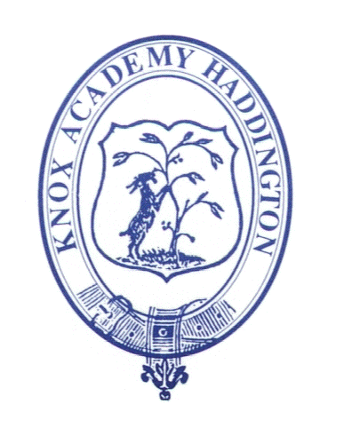
S1 Practice - Basics of a Major World Religion
- Christianity

Christianity is the world's biggest religion, with about 2.1 billion followers worldwide. It is based on the teachings of Jesus Christ who lived over 2,000 years ago.

The Basics

- Christians believe that Jesus was the son of God.
- They believe that Jesus was sent to earth to save everyone from their sin (the wrong things that they do).
- One of the most important concepts in Christianity is that of Jesus giving his life on the Cross (the Crucifixion) and rising from the dead on the third day (the Resurrection).
- Christians are monotheistic (this means they believe in only one God).
- Christians believe that there are three elements to this one God:
- God the Father
- God the Son
- The Holy Spirit
- Christians worship in churches.
- Their spiritual leaders are called priests or ministers.
- The Christian holy book is the Bible, and consists of the Old and New Testaments.
- Christian holy days such as Easter and Christmas are important milestones in the Western secular calendar.

Task 1.

- The Bible contains 10 rules for Christians to follow; these are called The Ten Commandments. Write your own 10 rules for life in the boxes below. Please write in full sentences ensuring you use capital letters and full stops.

Rule 1

Rule 2

Rule 3

Rule 4

Rule 5

Rule 6

Rule 7

Rule 8

Rule 9

Rule 10

PTO
Task 2.

Research Christianity using the internet and find 3 facts about the religion that are not mentioned in ‘The Basics' over the page.

1.

2.

3.

Task 3.

In your own words write a short biography on one of the following famous Christian people;

- Mother Theresa
- C.S. Lewis
- Martin Luther King Jr
- William Wilberforce
- John Knox
- Joan of Arc

You should include where they are from and when they were born, why they are famous, the importance of Christianity to them and your own thoughts and opinions on what they did.

