
S1 Practice
The Circus Within Me by Carl Sandburg

There is a wolf in me…fangs pointed for tearing gashes…
a red tongue for raw meat….
and hot lappings of blood.

There is a fox in me…a silver grey fox…I Sniff and guess…
I double pick things out of the air…I nose in the night…
I circle and loop and double cross.

There is a hog in me…a snout and a belly…a machinery for eating and grunting…
a machinery for sleeping satisfied…in the sun.

There is a baboon in me…clambering clawed…dog faced…
yawping a gallot’s hunger…hairy under the armpits…
ready to snarl and kill.

There is an eagle in me and a mocking bird…
and the eagle flies among the Rocky Mountains of my dreams…
and the mocking bird warbles in the early afternoon before the dew is gone.

Task

In class you have started thinking about/writing your own “Circus Within Me” poem. Your task at home for practice is to write/type your poem out on plain paper in colour so it can be displayed as a poster.

Success Criteria

- Your poem should have at least four animals which describe your personality e.g. “There is a mouse in me…quiet and shy…I run away from danger” etc. It can also be done as an acrostic with your name.
- Your poem should be eye-catching and colourful
- Your poem should be imaginative and thoughtful
- Your poem should be neat with pictures
- If you are unsure of the task ensure you speak to your teacher before next week

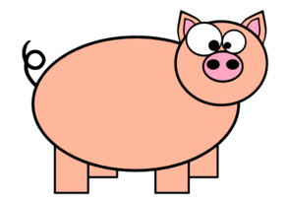
Good luck



