**Higher Administration**

**Homework Solutions**

**Administrative Services – Outcome 1 – Set 2**

**2008 CSQ2 - 6 marks**

Describe 3 ways in which a team may be affected by poor leadership.

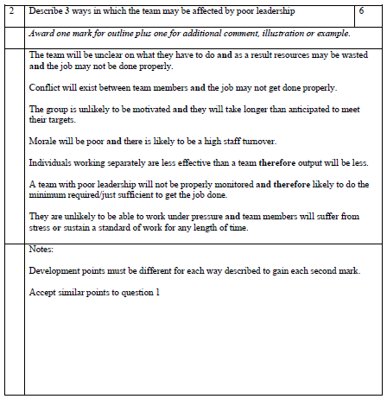

**2010 Q4d - 6 marks**

Describe 3 features of an effective team.

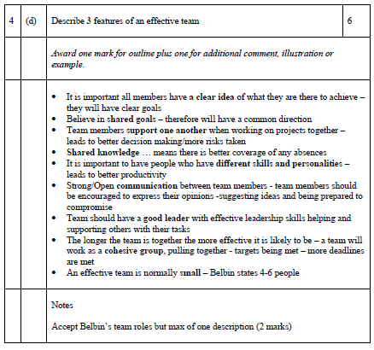

**2010 Q1c - 4 marks**

Outline 4 benefits of good leadership.

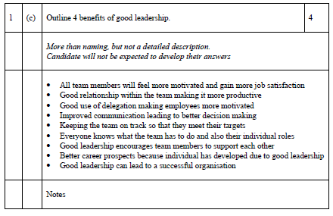

**2012 Q5c - 8 marks**

Discuss the advantages and disadvantages to an individual of working as part of a team.

