**Higher Administration**

**Homework Solutions**

**Administrative Services – Outcome 3 – Set 1**

**2010 Q1a - 4 marks**  
Identify 2 examples of items that would be included in a person specification and justify the purpose of this document in the interview process.

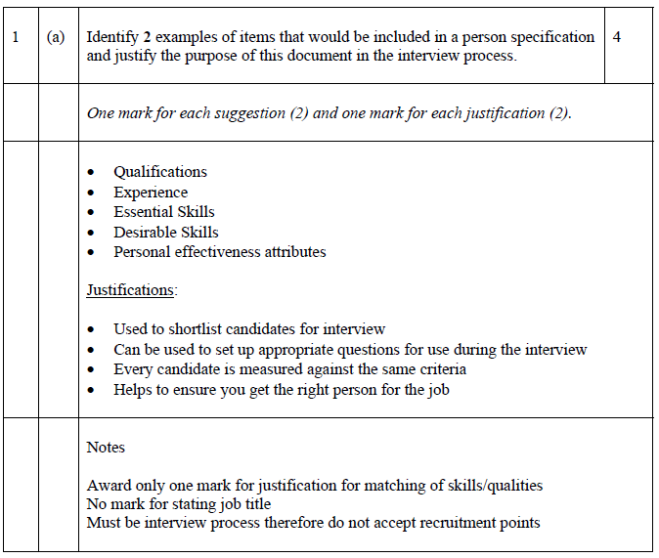

**2012 CSQ3 - 6 marks**  
Discuss advantages and disadvantages of using an agency in the recruitment and selection process.

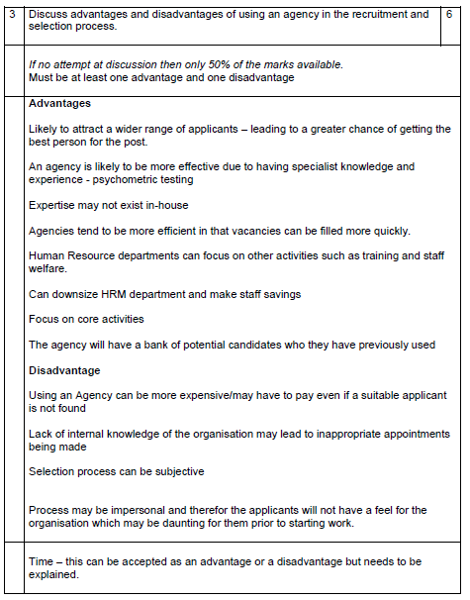

**2013 Q1c - 8 marks**  
Organisations interview applicants as part of the selection process.  
Discuss additional methods of selection that may be used to help choose the best candidate.

