**Higher Administration**

**Homework Solutions**

**Administrative Services – Outcome 3 – Set 2**

**2007Q3b - 4 marks**  
Outline benefits to an organisation of outsourcing the recruitment process.

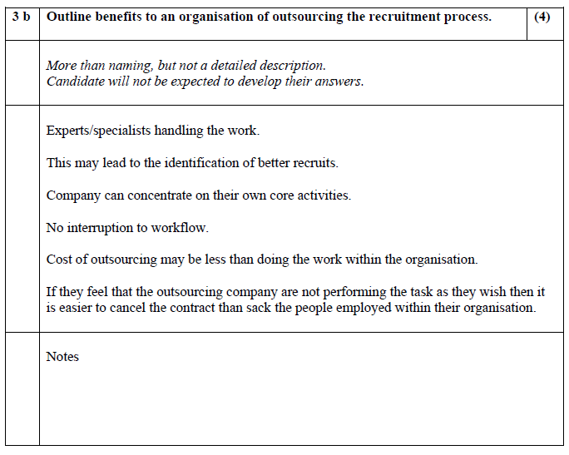

**2011 Q4d - 4 marks**  
Justify the need for an appraisal system as part of the staff development process.

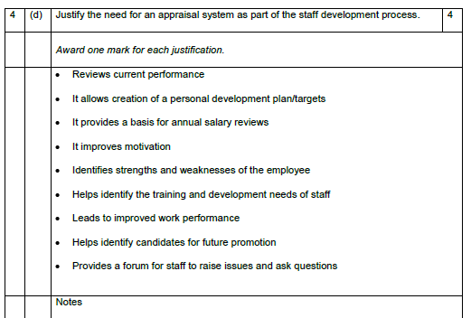

**2012 CSQ5 - 3 marks**  
Compare in-house and external training.

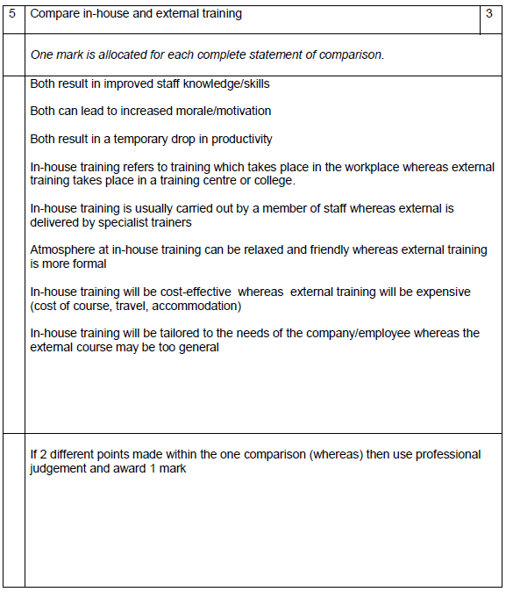

**2012 Q4d - 8 marks**  
Discuss the support systems which may be provided by Human Resources to enhance staff welfare.

