Knox Academy Science Department

Our Material World 1 Name:
Homework 3
Mark: /10

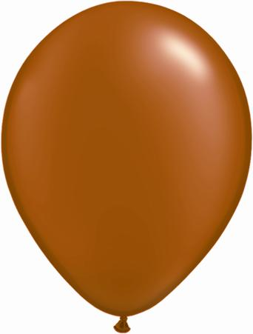
- When a balloon has been blown up, sealed and left for a few days its size is less than when it was first sealed.
On the reverse of this homework explain in terms of particles and a diagram why this has happened. (2)

- When perfume is sprayed at the front of the classroom it can be smelled at the back a short time later. Why is this?

What is this process called? (2)

3.

In this experiment the bar was removed from the gauge and heated strongly in a Bunsen Burner for 5 minutes. Its size was then rechecked in the gauge.

Complete the following: When the bar was returned to the gauge it was clear that its length had _____________ and its width had _____________. This shows that when the bar is heated the particles in it move ______________ and so move _______________. When any thing gets bigger we say it
_______________ and when anything gets smaller we say it
_____________. (6)

