Knox Academy Higher Physics

Properties of Matter Homework 1
9

Answer all questions.

1. | The density of steam at 100ºC is less than the density of water at 100ºC. The explanation for this is that when water changes to steam its particles
 | A | Move further apart.
 | B | Move with greater speed.
 | C | Have smaller mass.
 | D | Are no longer joined together.
 | E | Collide more often with each other.
4. | A rectangular box of mass 10kg is lying on a flat surface on a planet where the gravitational field strength is 4Nkg⁻¹.  The base of the box measures 4m by 2m.
 | 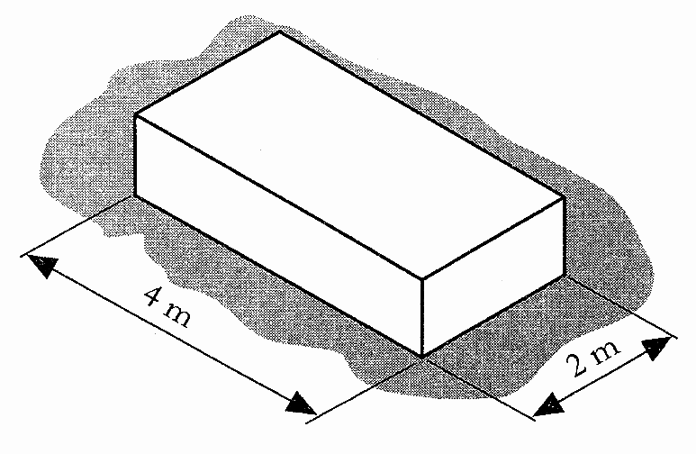
 | Which of the following statements is/are correct?
I The weight of the box is 100N.
II The weight of the box is 40N.
III The pressure which the box exerts
on the flat surface is 5Pa.
 | A | I only
 | B | II only
 | C | III only
 | D | I and III only
 | E | II and III only
2. | A student carries out an experiment to determine the density of a liquid.  The results are shown.
Volume of liquid in beaker = 2X10⁻⁵m³
Mass of empty beaker = 3X10⁻²kg
Mass of filled beaker = 4.5X10⁻²kg
 | The density of the liquid is
 | A | 4.44X 10⁻⁴ kgm⁻³
 | B | 1.33X 10⁻³ kgm⁻³
 | C | 7.50X10² kgm⁻³
 | D | 2.25X10³ kgm⁻³
 | E | 3.75X10³ kgm⁻³

5. | An aircraft cruises at an altitude at which the air pressure is 0.4X10⁵Pa. The inside of the aircraft cabin is maintained at a pressure of 1.0X10⁵Pa. The area of an external cabin door is 2m².
 | What is the outward force produced on this door by the pressures stated?
 | A | 0.3X10⁵N
 | B | 0.7X10⁵N
 | C | 1.2X10⁵N
 | D | 2.0X10⁵N
 | E | 2.8X10⁵N
3. | A 2000kg load rests on a steel shelf.  The base of the load is 0.5m².
 | 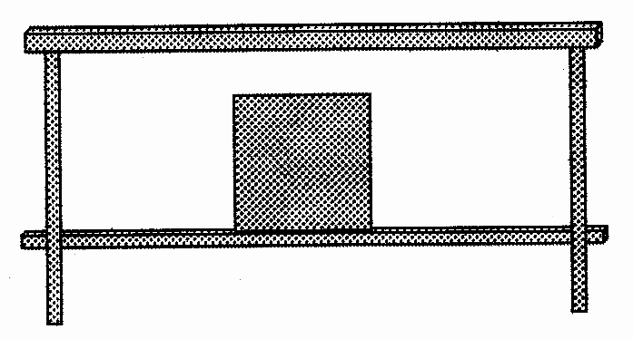
 | The pressure that the load exerts on the shelf is:
 | A | 500 Pa
 | B | 1000Pa
 | C | 8000Pa
 | D | 19600Pa
 | E | 39200Pa

6. | Which of the following gives the approximate relative spacings of molecules in ice, water and water vapour?
 |  | Molecular spacing in ice/units | Molecular spacing in water/units | Molecular spacing in water vapour/units
 | A | 1 | 1 | 10
 | B | 1 | 3 | 1
 | C | 1 | 3 | 1
 | D | 1 | 10 | 10
 | E | 3 | 1 | 10

7. | The apparatus in the diagram below may be used to measure the density of air. | Marks
 | 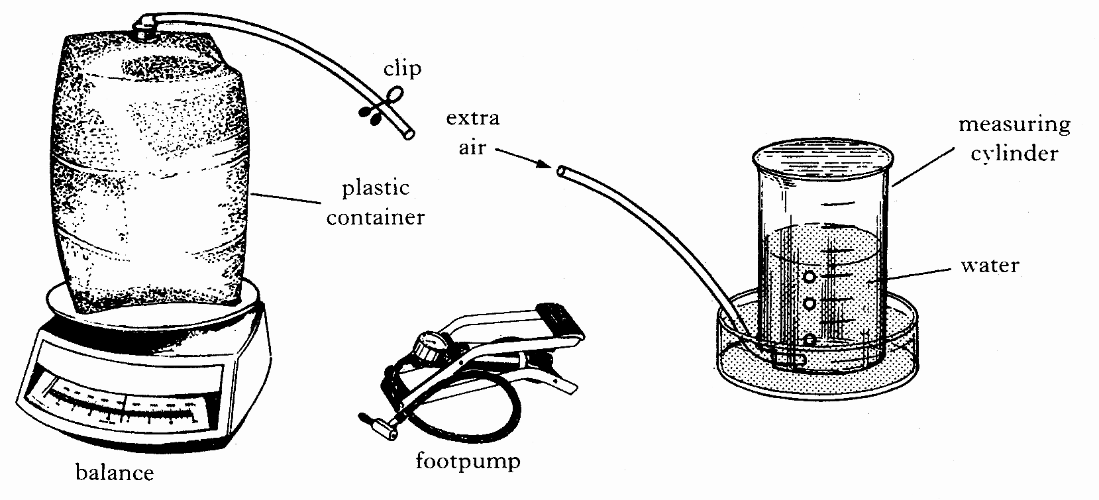
 | Using the footpump, extra air is pumped into the container. This extra air is released into the measuring cylinder as shown above and its volume measured.  The following measurements are recorded.  Mass of container full of air = 362.00g  Mass of container with extra air = 363.86g  Volume of air released = 1687.00cm³  What value do these results give for the density of air in kgm⁻³? | 3

