Knox Academy Higher Physics

Properties of Matter Homework 2
24

Answer all questions.

1. | A balloon of volume 6.0m³ contains a fixed mass of gas at a temperature of 300K and a pressure of 2.0kPa. The gas is heated to 600K and the pressure is reduced to 1.0kPa.  The new volume of the gas is
 | A | 1.5m³
 | B | 3.0m³
 | C | 6.0m³
 | D | 12.0m³
 | E | 24.0m³
3. | The end of a bicycle pump is sealed with a small rubber stopper. The air in chamber C is now trapped.
 | 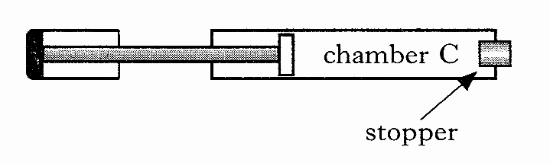
The plunger is then pushed in slowly, causing the air in chamber C to be compressed. As a result of this, the pressure of the air increases.
Which of the following explain(s) why the pressure increases, assuming that the temperature remains constant?
I The air molecules increase their
average speed.
II The air molecules are colliding
more often with the walls of the
chamber.
III Each air molecule is striking the
walls of the chamber with greater
force.
 | A | II only
 | B | III only
 | C | I and II only
 | D | I and III only
 | E | I, II and III

2. | After a car has been parked in the sun for some time, it is found that the pressure in the tyres has increased.  This is because
 | A | The volume occupied by the air molecules in the tyres has increased
 | B | The force produced by the air molecules in the tyres acts over a smaller area
 | C | The average spacing between the air molecules in the tyres has increased
 | D | The increased temperature has made the air molecules in the tyres expand
 | E | The air molecules in the tyres are moving with greater kinetic energy

4. | A solid at a temperature of -20ºC is heated until it becomes a liquid at 70º.  He temperature change in Kelvin is
 | A | 50K
 | B | 90K
 | C | 343K
 | D | 363K
 | E | 596K

5. | A skin diver carries her air supply in a steel cylinder on her back. She works at a depth where the pressure is 2.5X10⁵Pa. When full, the cylinder contains 0.060m³ of air at a pressure of 1.6X10⁷Pa.  Calculate the volume of air available to her at this depth from a full cylinder. | Marks  3

6. | Liquid nitrogen changes to its gaseous state at a temperature of -196ºC. |  | Marks
 | (a) | What is this temperature in Kelvin? | 1
 | (b) | Explain why a temperature of 0 kelvin is described as “the absolute zero of temperature”. | 2
 |  |  | (3)

7. | The apparatus used to investigate the relationship between volume and temperature of a fixed mass of air is shown. |  | Marks
 | 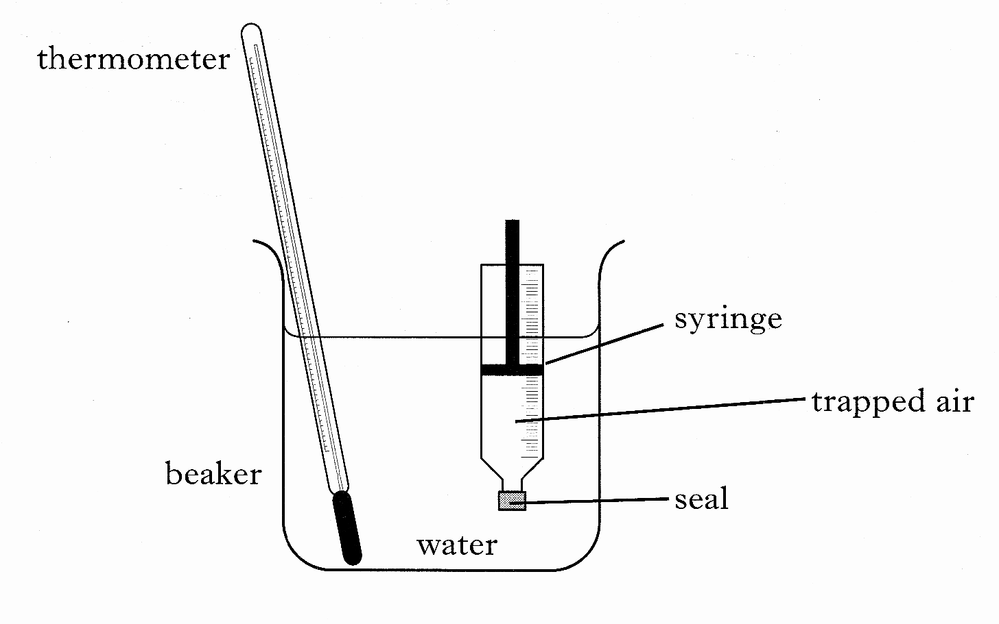
The volume of the trapped air is read from the scale on the syringe.
The temperature of the trapped air is altered by heating the water in the beaker. It is assumed that the temperature of the air in the syringe is the same as that of the surrounding water. The pressure of the trapped air is constant during the investigation.
 | Readings of volume and temperature for the trapped air are shown.
Temperature/ºC | 25 | 50 | 75 | 100
Volume/ml | 20.6 | 22.6 | 24.0 | 25.4
 | (a) | Using ALL the data, establish the relationship between temperature and volume for the trapped air. | 2
 | (b) | Calculate the volume of the trapped air when the temperature of the water is 65ºC. | 2
 | (c) | Use the kinetic model of gases to explain the change in volume as the temperature increases in this investigation. | 2
 |  |  | (6)

8. | A refrigerated cool box is being prepared to carry medical supplies in a hot country. The internal dimensions of the box are 0.30m x 0.20m x 0.50m. |  | Marks
 | 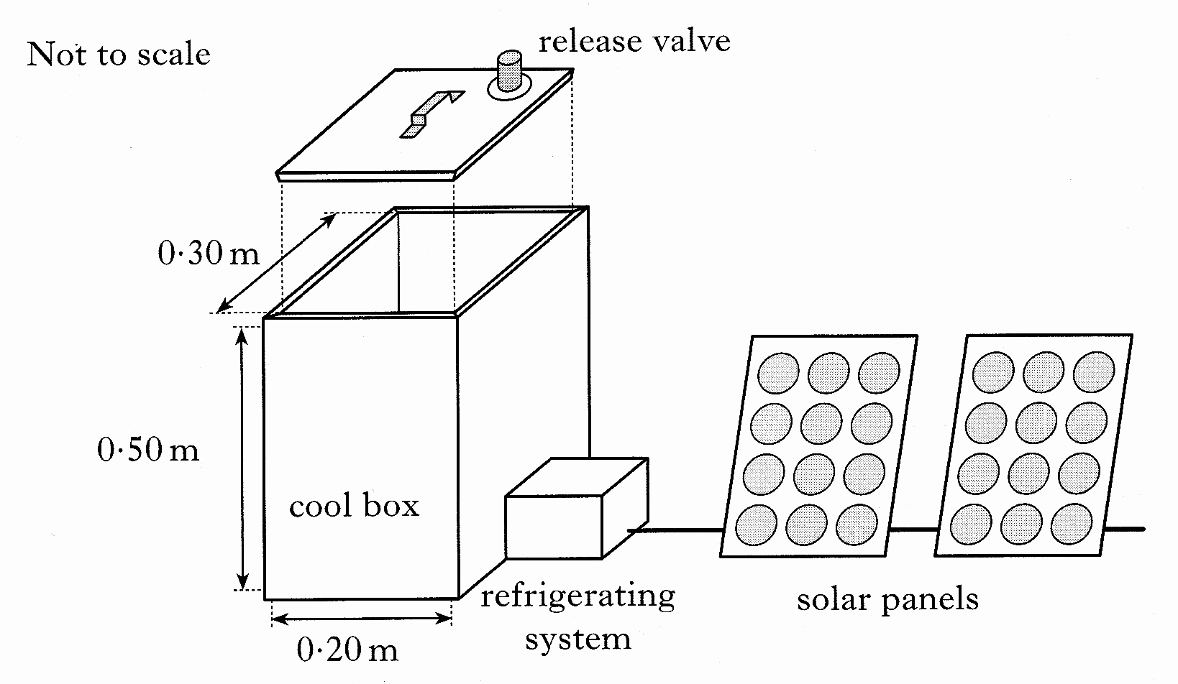
The lid is placed on the cool box with the release valve closed. An air tight seal is formed. When the lid is closed the air inside the cool box is at a temperature of 33ºC and a pressure of 9.05 x 10⁴Pa.
The refrigerating system then reduces the temperature of the air inside the cool box until it reaches its working temperature.
At this temperature the air inside is at a pressure of 9.05 x 10⁴Pa.
(a) | (i) | Calculate the temperature of the air inside the cool box when it is at its working temperature. | 2
 | (ii) | Describe, using the kinetic model, how the decrease in temperature affects the air pressure inside the cool box. | 2
(b) | (i) | Atmospheric pressure is 1.01 x 10⁵Pa.  Show that the magnitude of the force on the lid due to the difference in air pressure between the inside and the outside of the cool box is now 630N | 2
 | (ii) | The mass of the lid is 1.5kg.  Calculate the minimum force required to lift off the lid when the cool box is at its working temperature. | 1
 | (iii) | The release valve allows air to pass into or out of the cool box. Explain why this valve should be opened before lifting the lid. | 1
 |  |  | (8)

