Knox Academy Higher Physics

Properties of Matter Homework 3
15

Answer all questions.

1. | A polystyrene float is held with its base 2.0m below the surface of a swimming pool.
 | 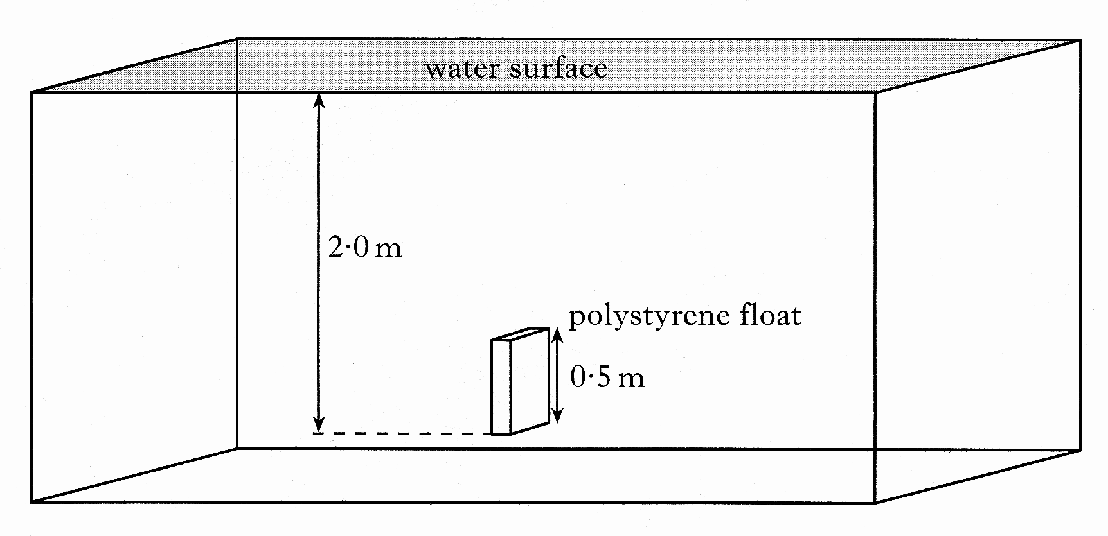
 | (a) | The float has a mass of 12g and its dimensions are 0.50m x 0.30m x 0.10m.  Calculate the density of the float. | 2
 | (b) | Explain why a buoyancy force acts on the float. | 2
 | (c) | The float is released and accelerates towards the surface. Taking into account the resistance of the water, state what happens to the acceleration of the float as it approaches the surface. You must justify your answer. | 2
 | (d) | Another float made from a more dense material with the same dimensions is now held at the same position in the pool.  The float is released as in part (c).  State how the initial acceleration of this float compares with the polystyrene float. You must justify your answer. | 2
 |  |  | (8)

2. | Which pair of graphs shows how the pressure produced by a liquid depends on the depth and density of the liquid?
 | 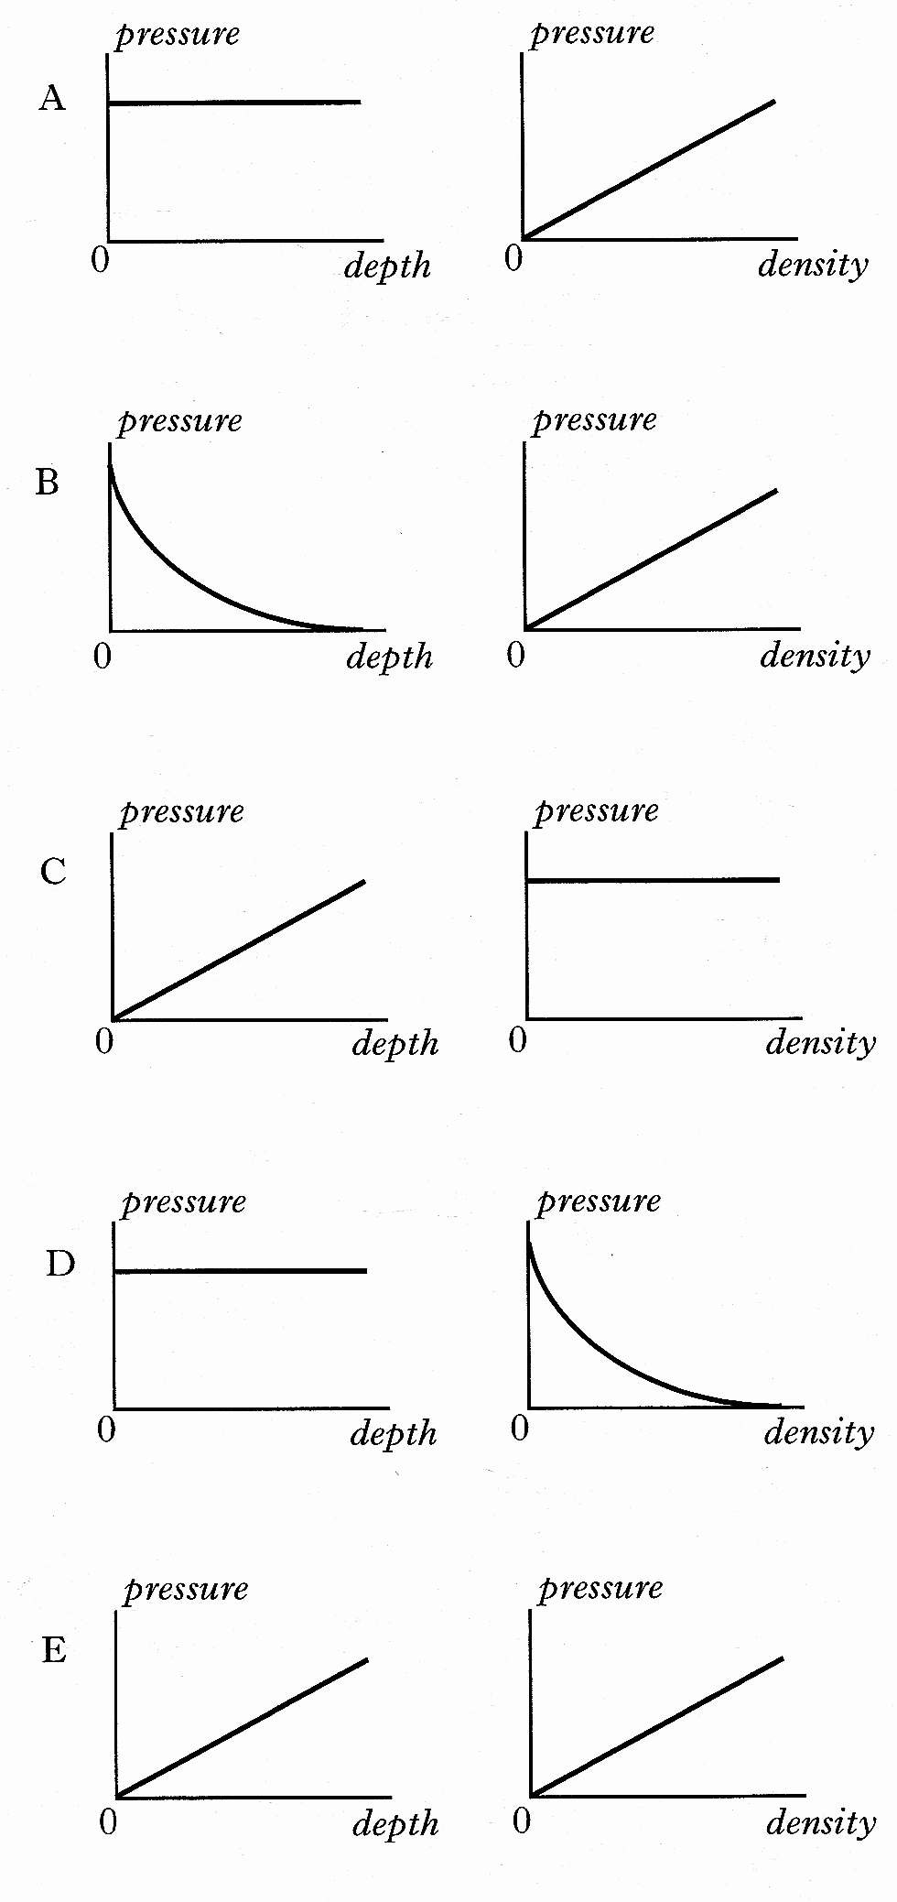
3. | A small metal block is suspended from a spring balance at a depth h below the surface of a liquid in a large beaker.
 | 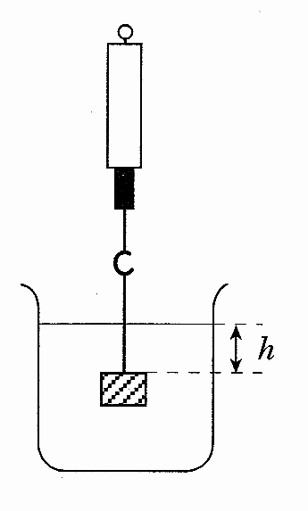
Which of the following statements is/are true?

I The reading on the spring balance
depends on the density of the liquid
in the beaker.
II The reading on the spring balance is
equal to the upthrust of the liquid on
the metal block.
III The reading on the spring balance
will increase as the depth h is
increased.

 | A | I only
 | B | II only
 | C | III only
 | D | I and II only
 | E | I and III only

4. | A 10kg cylinder is anchored to the bottom of a pond. The upthrust of the water is 150N
 | 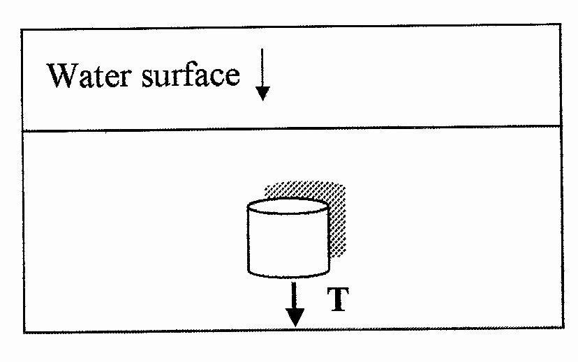
 | The forces T, holding the cylinder down is:
 | A | 15N
 | B | 52N
 | C | 98N
 | D | 150N
 | E | 248N

5. | A mooring buoy is tethered to the sea bed by a rope which is too short. The buoy floats under the water at high tide. The weight of the buoy is 50N.
 | 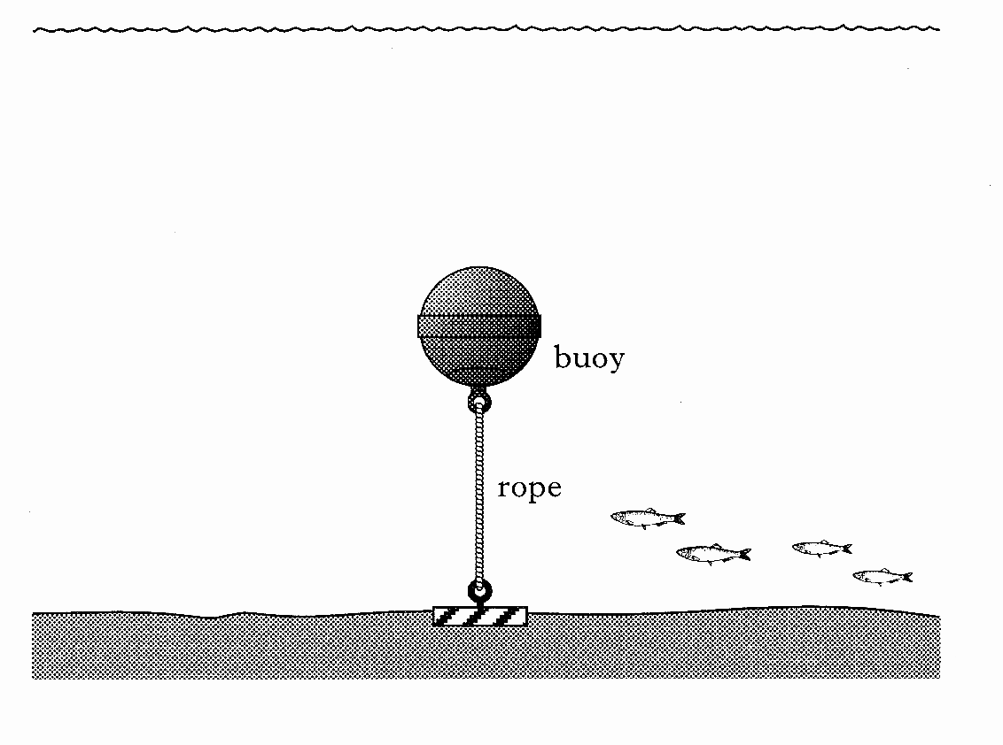
(a) | (i) | Draw a labelled diagram to show all the forces acting on the buoy in the vertical direction. | 1
 | (ii) | The tension in the rope is 1200N  Calculate buoyancy force. | 2
(b) |  | The rope now snaps and the buoy starts to rise. What is the size of the buoyancy force ob the buoy when it is just below the surface of the water? | 1
 |  |  | (4)

