National 4/5 Administration:
Communication in Administration

Emerging Technologies

Blogs:
Blogs are setup on the Internet by individuals who wish to communicate their thoughts and opinions on a particular topic; there are blogs on virtually anything you can think of – photography, business education, receipes, personal diaries, hobbies etc. Blogs can bring people from around the world who share similar interests together to share ideas, make friends and even do business together.

Discussion Groups and Forums:
A discussion group is an online forum for individuals to discuss topics of interest. Posters add their comment, which others can read and then respond to. It is an informal and voluntary way to exchange ideas and information and keeps people up-to-date on topics of interest.

Instant Messaging:
Instant Messaging (IM) is a way of communicating in real time (instantly). You can send IMs to anyone who is online at the same time, and you can reply immediately to messages sent to you, and so on. Two or more people can join in a ‘conversation’ at the same time. IMs can be used to have a quick conversation between colleagues working on the same project in different areas of the office. Instant messaging is not a secure method of communication.

Podcasts and Vodcasts:
Podcastiong/vodcasting is an audio/visual file which can be downloaded to a computer or mobile device (such as a smartphone or tablet). It means that people can listen or watch at a time that is convenient to them.

Websites:
Many organisations will have their own website. They will use this to communicate with customers – promoting their products with pictures, product details (size, colour etc) and customer reviews – to encourage people to buy the product or service. Many organisations have an e-commerce facility on their website, which allows customers to purchase products online. Organisations will also use their website to keep (potential) customers informed of special offers etc.

Social Media:
Social media is a way of talking to other people via your computer, allowing you to exchange pictures, information, ideas, opinions etc. Social media is becoming more popular with businesses as a way to communicate with customers and potential customers.

Twitter – an information network that connects people to the latest stories, ideas, opinions and news. Individuals choose to ‘follow’ whoever interests them, whether this is an individual, business, news outlet etc. Businesses can use Twitter to quickly share information about their products and services. It also allows a ‘conversation’ between the follower and the business about a product/service, which can then be ‘retweeted’ to many more potential customers.

Facebook – a social networking site that lets you connect with friends, co-workers, and others who share similar interests or who have common backgrounds. Businesses use these services as it gives them direct access to customers and potential customers.

LinkedIn is a business version of Facebook – it connects individuals with people they know on a professional basis. It allows the user to see other people’s business contacts and to ask for introductions in order to do business with them.

Virtual Learning Environments (VLEs) use the Internet to allow remote access to learning materials, for example notes, tasks, homework, tests etc. Students can either work through the materials at their own pace before submitting to the ‘teacher’ for checking and tracking, or they can participate while a teacher conducts a live class – communicating through a microphone, chat rights, or by writing on the ‘board’. Edmodo is a VLE that you may have used in school.

It may also be used to:
- advertise products and job vacancies (perhaps using social media)
- e-commerce – selling online 24/7 (or buying from suppliers)
- contacting customers/suppliers via email
- web conferencing – face to face discussions eg using software such as Skype

Choosing a Method of Communication:

When communicating with customers, clients and employees it is important that the correct method of communication is used:
- Is it appropriate? Will all intended recipients receive the information?
- Is it the most cost effective
- How quickly is the information required?

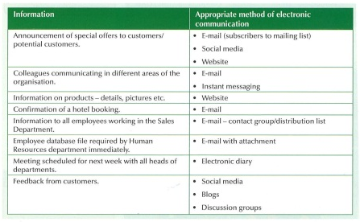

Answer the following questions in the table on the right….

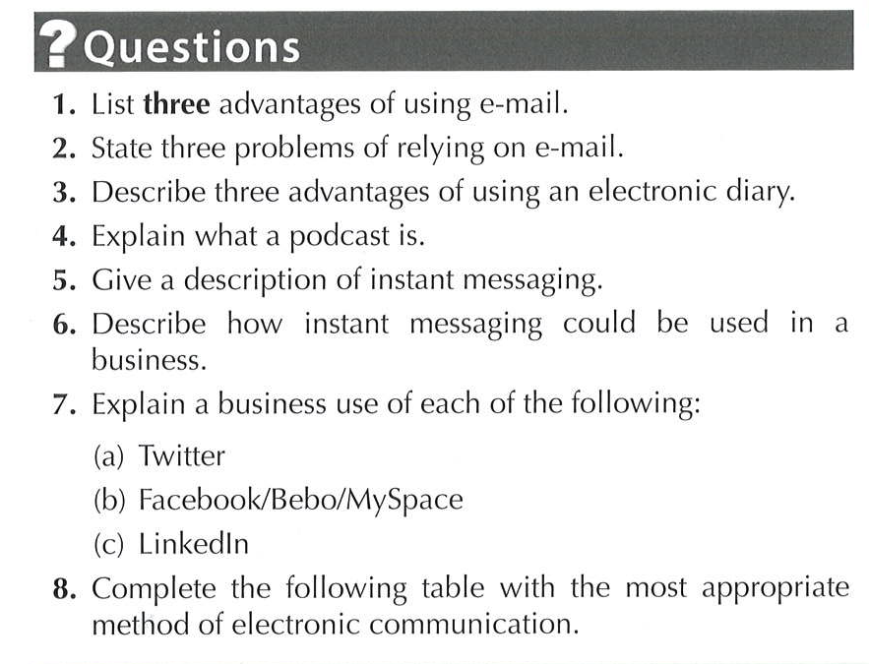
1
2
3
4
5
6
7
8

Complete the task below ….

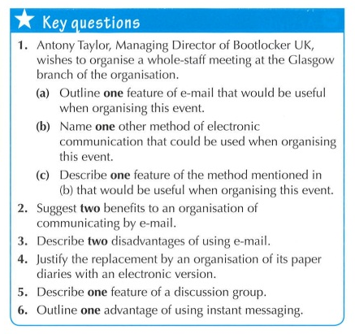
Answer the questions in sentences, delete the “Key Questions”, format this page appropriately, then print only this page.

Remember to add your name in a footer.

