National 4/5 Administration:
Communication in Administration

Using technology to extract information and evaluate sources of information

The internet (which is a Wide Area Network [WAN]) can be used to find information such as:
- Travel/accommodation information
- Foreign travel advice
- Travel routes/maps/traffic advice
- Competitors prices/promotions
- Latest business news
- Government publications

It may also be used to:
- advertise products and job vacancies (perhaps using social media)
- e-commerce – selling online 24/7 (or buying from suppliers)
- contacting customers/suppliers via email
- web conferencing – face to face discussions eg using software such as Skype

Complete the following table showing definitions of the terms:

Web Browser
URL
Search Engine
Homepage
Hyperlinks
Download
Bookmarks/Favourites

Advantages of using the internet as a source of information:
- Information is usually up-to-date – many websites are updated in a regular basis to give the latest prices, availability etc.
- A vast range of information is available – this gives users access to much more information than they previously could have gathered.
- Websites may give more detailed information than printed materials like brochures or catalogues – many hotels have ‘virtual tours’ on their website
- Convenience – users can access information at a time when it is convenient to them
- Information is instantly available, for example the seat availability is shown when booking flights.

Accessing reliable information on the Internet:
- Users of the Internet must be selective about the sources they take information from. Anyone can create a website with information that may be inaccurate and therefore unreliable.
- Users relying on the Internet for accurate information should only use websites that are reputable or from a well-known organisation, for example government websites or major news websites.
- Users should also try to ensure they use a website that is updated on a regular basis. These websites are more likely to be accurate.
- Users should look carefully at the website – if the site looks poorly designed and substandard it probably has not been created by a professional and chances are that it will not be reliable.
- Use a secure website, particularly if using credit card or other method of payment over the internet. A secure website will have a padlock sign on it or https:// in the address, showing that it is a verified website and uses encryption.

Consequences of using unreliable internet sources of information:
Using out of date information is worse than having no information at all, eg an inaccurate train timetable could result in missing an important meeting.

It is important to check that information is accurate and free from bias. This is important if you were writing a report making recommendations based on the information that you had researched.

If secure websites are not used and websites are hacked, sensitive/personal information may be stolen. This could include credit card and bank details.

An Intranet
An internal computer network used to share information within an organisation.

Employees can access information on company events, current policies, staff newsletters, product information and price lists, internal telephone numbers etc. The intranet may also store files that employers need to download and complete, such as expense claim forms, accident report forms etc.

Advantages of an intranet:
- All employees have access to the same current information
- Time is saved as information only needs updated once
- All information is stored electronically reducing paper and photocopying costs
- Communication (particularly in a large organisation) is improved through use of systems such as internal email and electronic diaries.

Answer the following questions in the table on the right….

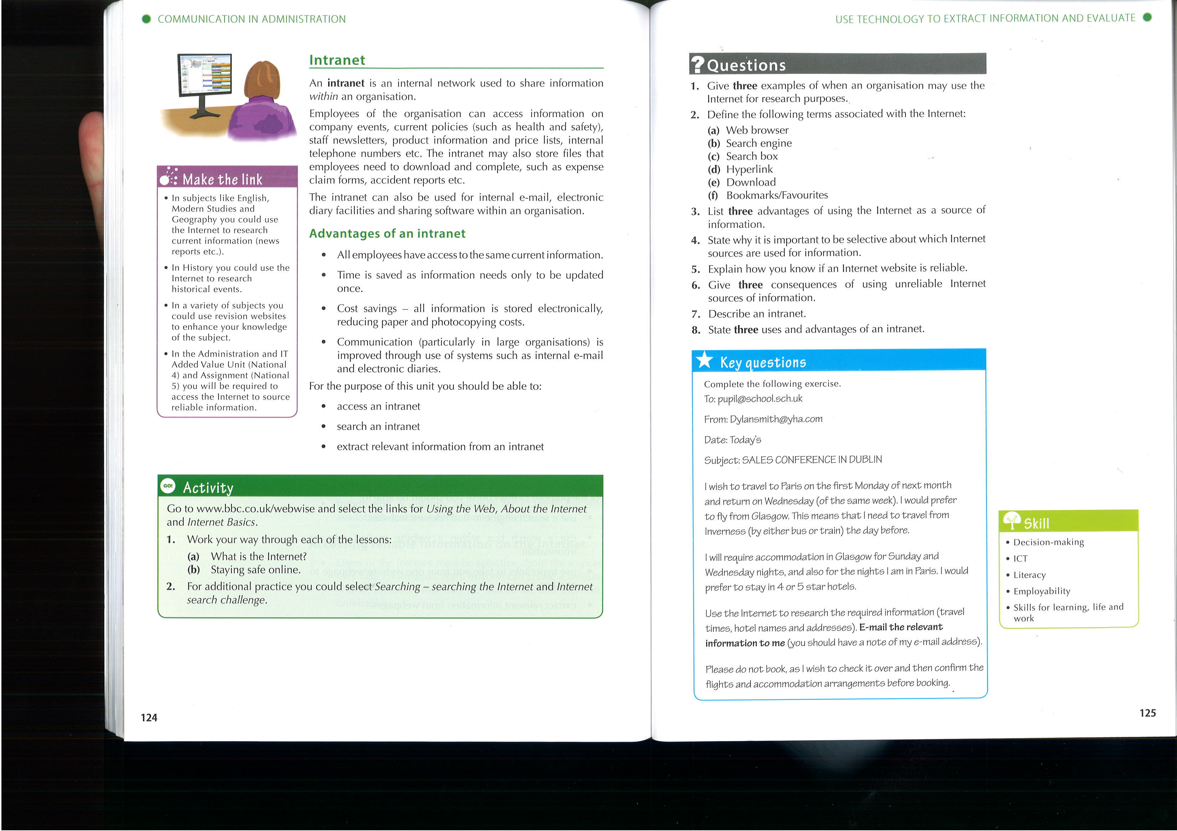
1
2 | a
 | b
 | c
 | d
 | e
 | f
3
4
5
6
7
8

Complete the task below (you may wish to record the information in the table on the left before you send the email)
First Monday of next Month (Date)
Wednesday of that Week (Date)
Accommodation (Name/Address)
Rail/Coach Information (Times etc)

You should now format this page appropriately based on the length of your answers.

Enter your name in the footer of this document and print only page 3

