1. What is Energy?
Energy lets us do things (or do work).
The main types of energy are:
- L _ _ _ _ energy
- H _ _ _ energy
- S _ _ _ _ energy
- E _ _ _ _ _ _ _ _ _ energy
- M _ _ _ _ _ _ _ energy
- Stored; G _ _ _ _ _ _ _ _ _ _ _ _ energy
Stored; C _ _ _ _ _ _ _ energy
Stored; E _ _ _ _ _ _ energy
- N _ _ _ _ _ _ _ energy

In each box write a sentence to say what energy was there at the start and what kind of energy it changed into at the end. (the first one is done for you)

Striking a match  Stored chemical energy in the match is changed into Heat and light energy. | 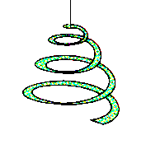  Paper spiral above  Bunsen flame
Metal gauze  Metal tube  Sounding Tube | Pendulum  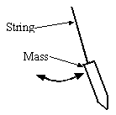
+  ­  Battery and bulb | PC
+  ­  Battery and bell | M  +  ­  Battery and motor
The Sun  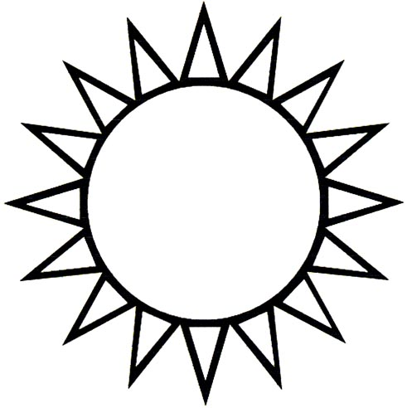 | G  Dynamo (Generator)  and bulb
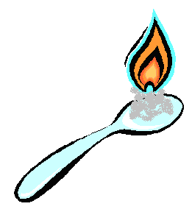  Set fire to sugar |   Sparkler

2. Stored Energy
In Each group of energies below circle the odd one out (the reason it’s the odd one out is the same for each group).
- Sound, elastic, electrical.
- Gravitational, kinetic, light.
- Heat, nuclear, chemical.

In each box (or beside the box) write down which energy was there at the start and what energy was there at the end.

Catapult  Air  pushed out  Balloon  moves  Paper pellet  Elastic | Balloon
Car down a slope | Dropping  mass  Motor / dynamo  Mass
Magnesium ribbon  Methane Gas  Air taken in  Burning gas tin | Magnesium burning in air

Energy can be stored in three ways:

- Stored _____________energy: By lifting an object up
against gravity.
- Stored _______________ energy: By squashing or
stretching an object.
- Stored _____________ energy: The energy stored in
chemicals that react together.

3. Changing Energy
To show where the energy has come from and where it goes in any situation, an energy chain can be drawn. Complete the following energy chains.

1. Energy Chain for person jogging:
_________ energy of whole body
plus
________ energy released inside muscles
_________ energy stored in food

2. Energy chain for a battery powered radio:
_______ energy out of the speaker
_________ energy in the wires
Chemical energy stored in the _________

3. Energy chain for television:
_______ energy in the screen
plus
Sound energy from the _________
Electrical energy in the _________

4. Energy chain for car driving with its lights on.
Electrical energy in the _________
_________ energy in the Petrol
Light energy and _______ energy in the headlights _________

Movement (or __________) energy of the car _________

Experiment 1. A lab pack was connected to a buzzer so that a sound was made. Draw a diagram of the circuit that did this here:

energy produced by the
buzzer

energy in the lab pack and wires

Experiment 2. A lab pack powered a small motor which lifted a weight from the floor. An energy chain to show what happens in this experiment is-

4. Electrical Energy

Fossil Fuels
Almost all of the electrical energy produced in the UK at the moment comes from power stations that burn
f_ _ _ _ f_ _ _ _ .
Fossil fuels are formed from the compressed remains of dead p_ _ _ _ _ and a_ _ _ _ _ _ that lived millions of years ago.
C_ _ _ , o_ _ and natural g_ _ are all fossil fuels.

Power Stations
Power stations that burn fossil fuels transform the
c_ _ _ _ _ _ _ energy stored in the fossil fuels into useful
e_ _ _ _ _ _ _ _ _ energy. This electrical energy is transferred to our homes through a network of power lines and pylons called the N_ _ _ _ _ _ _ Grid.

A Model of a Power Station.

________energy is stored in the gas going into the Bunsen burner. As the gas burns the two types of energy are produced are _________energy and ________ energy.
The steam has __________ energy when it comes out of the vent. The turbine has __________ energy as it spins.

In order to make electricity the moving turbine is connected to a m_ _ _ _ _ . The magnet turns close to a coil of wire and e_ _ _ _ _ _ _ _ _ _ is produced.

This __________ energy is fed into the National Grid, which supplies our homes. The used steam is turned back into liquid water in the __________, this water is then fed back into the __________ to be used again.

Write down an energy chain that shows the energy changes that take place in our model power station:

5. Renewable Energy

Fossil fuels are called ‘non-renewable’ energy sources because______________________________________________________________________________________
______________________________________________

The two main problems with burning fossil fuels are:
1. _____________________________________________
_____________________________________________

2._____________________________________________
_____________________________________________

The name given to energy sources that will not run out is
r_ _ _ _ _ _ _ _

Energy Sources: Write one advantage and one disadvantage of each of the following energy sources in the boxes.

Energy Source | Renewable or not? | Advantages | Disadvantages
Fossil fuels | Non-renewable
Nuclear | ?
Solar | Renewable
Hydro electric/tidal | Renewable
Wind | Renewable
Wave | Renewable
Geothermal | Renewable
Biomass | Renewable
6. Energy Island
Using your completed map write a report here to the Knox Explorers explaining:
1. What kind of renewable energy sources you have chosen.
2. The position of your energy sources
3. How many of each source you will need to build.

7. Investigating Solar Cells
Label the apparatus we used in this experiment on the following diagram. (use the words solar cell, ruler, voltmeter, bulb, power supply)
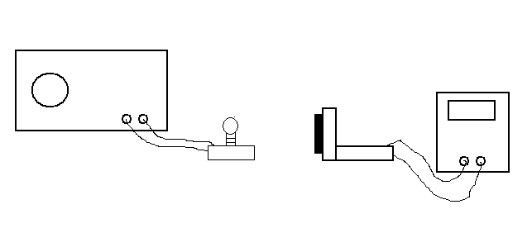
The things that might affect how much electrical energy is produced by the solar cell are ___________________ and ___________________ and______________________
I am going to investigate whether the d__________ that the bulb is away from the solar cell affects how much e________ e__________ the solar cell produces.

Record the output of the solar cell at different distances from the bulb in the following table:

Distance between bulb and solar cell (centimetres) | Voltage output of solar cell  (volts)
0
5
10
15
20
25

Draw a line graph on graph paper to show your results and staple it into your booklet (put distance on the bottom y-axis and voltage on the upward x-axis).

Draw a best fit line through your points. Staple the graph into your booklet.

Conclusion: I found that as the distance between the bulb and the solar cell went up the output of the solar cell went _______________ .

I kept the experiment a fair test by keeping the _______________the same for each reading and by keeping the _______________ the same for each reading.

8. Batteries
Three things that get the energy they need to work from batteries are:
1.
2.
3.

The main advantage of using a battery to supply energy to a device is ______________________________________

Two disadvantages of using batteries to supply energy to a device are: ____________________________________ and __________________________________________

Investigating a simple cell (battery)

Activity: Experiment 1 - Charging:

Power Supply

Lead Electrodes

Sulphuric Acid

00.00

Beaker

stopwatch
Diagram 1
(charging)

We stored energy in our simple battery by connecting it to a power supply. The energy was stored as c_________ energy in the liquid. This is called c_________ the cell.
In the space below write down the energy changes that are taking place as the cell charges:

Experiment 2 - Using Your Charged Cell

1.5V Bulb

Diagram 2
(discharging)
00.00
stopwatch

Lead Electrodes

Sulphuric Acid

We charged our cell for different lengths of time and then found out how long the cell could light a bulb for using the s_ _ _ _ _ _ _ _ .

Time battery charged for  (minutes) | Time bulb lit for  (seconds)
3 minutes
2 minutes
1 minute

The __________ the time the cell was charged for, the __________ chemical energy was stored in it and the __________ it could light the bulb.
Word bank: longer, shorter, more ,less

9. Energy in Foods
Demonstration to show that food contains energy.
Burning candle
Custard Powder
Blow into the tube

A puff of air was sent down a tube causing the powdered food to be _ _ _ _ _ into the air.
When the custard came in contact with the candle the flame set _ _ _ _ to it causing the lid of the can to be _ _ _ _ _ off.

Complete the energy chain for this experiment :

M _ _ _ _ _ _ _ energy as the lid flew off
H _ _ _ energy in the flames
L_ _ _ _ energy in the flash
S _ _ _ _ energy in the bang
C _ _ _ _ _ _ _ energy in the food

Our bodies also release the energy stored in food but our bodies release the energy more s _ _ _ _ _ _ and with less
h _ _ _ energy produced.

Do all foods contain the same amount of energy?
We set fire to different foods to release the stored
c _ _ _ _ _ _ _ e _ _ _ _ _ . The l _ _ _ _ _ the food burns for the more energy it contains.

Food | Burning time (seconds)

In the boxes below write an energy chain to show what happened to the energy as the food burned.
Chemical Energy stored in the f _ _ _
H _ _ _ and L _ _ _ _ energy

We keep the test fair between the different foods in this experiment by making sure we used the _ _ _ _ amount of food each time
The food which food contained the most stored chemical energy was _________________
The food that contained the least stored chemical energy was ________________

10. Looking at Light Energy
We can see things that produce their own light e.g. a candle flame or light bulb - the light goes straight from the object into your eye.

To see an object that does not produce its own light, light has to bounce off that object then go into your eye.

Draw arrows on the above two diagrams to show the path of the light beams in each case.
We can see an object either when it__________ light of its own or when light __________off it and then enters our __________. Light travels in _________ lines.

‘Bending’ Light
Draw a diagram in the space below to show how the pencil looked when it was in the water.

The pencil looked __________ when it was in the water. This must be because the light from the bottom half of the pencil ___________ when it hits the surface.

We shone a beam of light at a glass block. Complete the diagram to show the path of the ray inside the block.

Glass block
Light beam

When light hits the boundary between two transparent (see-through) substances it c _ _ _ _ _ _ direction.

11. More about Light Energy
White, Black and Colour

White light
prism
Ray Box
paper

Ray box

Complete the diagram to show what appeared on the screen. List any colours that appeared on the diagram in the order that they appeared.

White light is a mixture of all the colours of the rainbow. In order these are:________, ________, ________, ________, _______, ________, ________. White light can be split into its separate colours using a __________.

Why do objects appear coloured?
A red object appears red when white light is shone on it because it a _ _ _ _ _ _ (takes in) all of the colours except red, which it reflects into your e_ _ _ .
The following diagram shows what happens.
White Light
(all the colours mixed together)

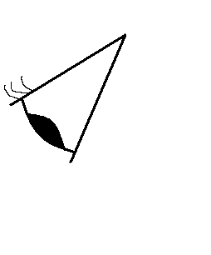
eye

Red Light
Red Object

What colours of light does white paper absorb in order to appear white? Answer:

What colours of light does black paper absorb in order to appear black? Answer:

Colour Filters.
A colour filter is a piece of plastic or glass that only lets one colour of light pass through it
What colour would a green object appear to be if you looked at it through a red filter? Answer:

Explain why it would look this way:

12. Investigating Sound Energy
When something v _ _ _ _ _ _ _ (moves backwards and forwards) the energy from these vibrations can be passed into the air. Our ears detect the vibrating air as s _ _ _ _ .
The rate that the vibrations move back and forward is called the f_ _ _ _ _ _ _ _ .
Air particles ‘squashed together’

Air particles ‘stretched apart’

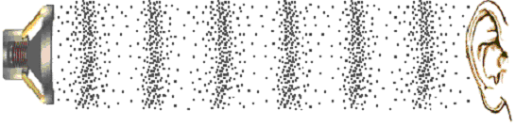

Can sound travel through other substances apart from air?
Draw a labelled diagram of your string telephone in action here:

We know sound can travel through other materials apart from air because:____________________________________
______________________________________________

We know sound travels better through string than air because:______________________________________________________________________________________

13. More about Sound Energy
Making Sounds
Three of the easiest ways to make something vibrate and so produce sound are:
- H _ _ it
- P _ _ _ _ it
- B _ _ _ over it
1. Blowing over the mouth of a bottle
When the size of the air column in the bottle increased the frequency of the sound produced __________ .

2. Tubular Bells
When the length of the tubes got longer the pitch of the sound made got__________. To make the sound louder we can make the tubes vibrate ________ by hitting them__________.
3. Vibrating speaker cone
To make the beads jump the paper cone of the speaker must be v _ _ _ _ _ _ _ _

4. Plucked String.
We made the wire produce sound by__________ As the tension in the wire increased the frequency of the sound produced _________.

5. Tuning Fork.
The end of the tuning fork was v__________ to produce sound.
6. Clamped Ruler.
The longer the piece of wood the __________the frequency of the sound produced.

7. Hitting a cymbal.
The harder the cymbal is hit the h_______ the grains of rice jump.

8. Shouting at a balloon.
When I shouted at the balloon I could feel the sound v________ my fingertips through the balloon.

9. Blowing through a straw
As the length of the straw ___________the frequency of the sound __________.

14. Sun and Earth
Most of the energy on Earth comes from the __________. The energy released in the sun comes from ___________ reactions. It travels across space to the Earth in the form of __________ energy. Green ________ collect the light energy and store it as __________ energy. We can take this energy into our bodies and use it ourselves by __________ plants.
Draw an Energy Chain below to show where you got the energy from to climb the stairs to get to your Science class.

Day/Night
Draw a diagram below to explain why all of the earth’s surface is not lit up by the sun at the same time.

The time the earth takes to spin round once is called a _ _ _ and takes _ _ hours.

Why is it hot at the equator but cold at the poles?
How hot it is at a particular part of the earth depends on how c _ _ _ _ _ _ _ the sunlight is on the ground. If the same amount of sunlight is spread over a bigger area the earth will be c _ _ _ _ _ at this spot.

Draw a diagram below to explain why it is hot at the earths equator but cold at the poles.

Summer/Winter
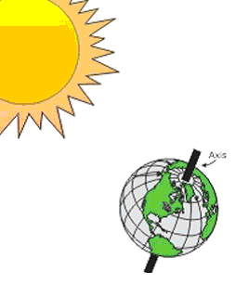
Earth spins on its own axis once every 24 hrs
Earth goes round the sun once every ~365 days
This axis is t _ _ _ _ _ compared to its orbit round the sun.
Because of this tilt the ‘top’ half of the earth is tilted away from the sun for some of the year- this is when this part of the earth would get its w _ _ _ _ _ .
Six months later the earth will be round the other side of the sun and the top half of the earth will be tilted t _ _ _ _ _ _ the sun- it will now get its summer.

