
Practice on Creation Stories

Task

In class you have been looking at a number of different creation stories and theories. Your task at home is to transfer one of these stories into storyboard form to be displayed in class. You can use the template provided or create your own one. Your storyboard can be on the Judaeo-Christian story, the Hindu story, the Aboriginal story, the Big Bang Theory or even something you have researched yourself.
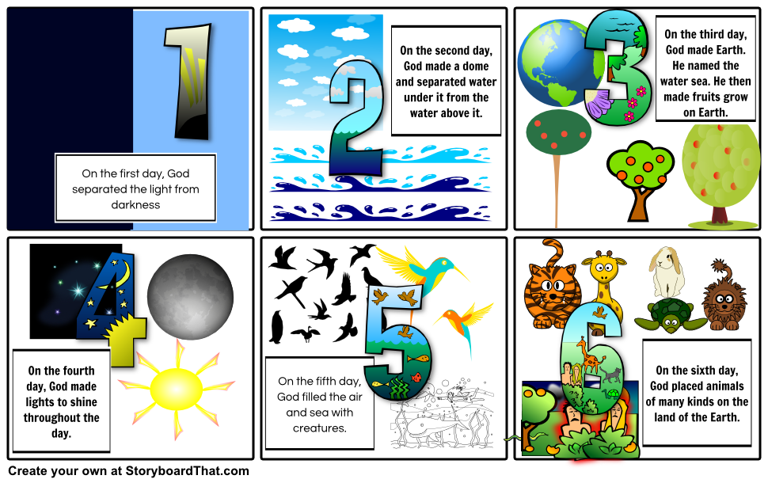
Success criteria

- Your storyboard should be eye-catching and colourful
- Your storyboard should contain text in full sentences and pictures
- Your storyboard should demonstrate your knowledge of a creation story or theory
- Your storyboard should be neatly written or typed
- If you are unsure of the task ensure you speak to your teacher before next week.
Good luck

