
S2 Practice – Kashrut

Task

In class you have been studying Judaism and this week specifically Kashrut (Jewish dietary laws). Your task at home is to design a menu for a Jewish café/restaurant.

Success Criteria

- Your café/restaurant should have a name
- Your menu should be eye catching and colourful
- Your choices should be attractive and imaginative
- Your choices must be kosher and not treyfah
- You should have a food and drinks section
- Your items should be priced
- You should include photos or pictures
- You should have at least one Kosher symbol on your menu

Kosher (Fit to eat) | Treyfah (Forbidden)
Animals with a split hoof (sheep and cow) | Horse
Fish with a backbone | Pig
Chicken | Seafood
Goat | Rabbit
All fruit and vegetables | Birds of prey
No blood | Reptiles

Remember, Meat and Dairy cannot be eaten in the same meal!

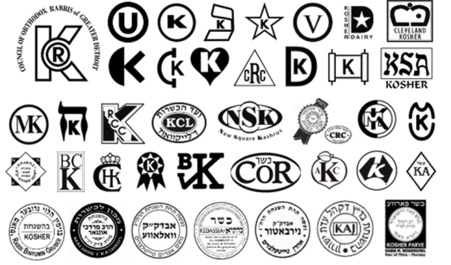

Good Luck

