
Practice on Ultimate Questions

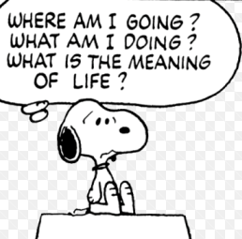

An Ultimate Question is a philosophical question with no “right” answer. These are the sorts of the questions people have discussed for centuries. Now you are going to start thinking about some of these BIG questions of life. You will already have discussed some of these in class.


Examples of Ultimate Questions

- Is there a God?
- What is the meaning of life?
- How did the Universe get here?
- What happens when we die?
- Why is there suffering in the world?
- There are so many religions in the world, can they all be right?
- What makes people happy?

Task

Your task is to write 100 words on your answer to one of the ultimate questions above (or a different one if you prefer).
Your answer will then be displayed on the Philosophy Tree so ensure it meets these success criteria.

- Is your 100 words interesting and informative?
- Have you given your opinion?
- Have you included the opinion of someone else who might think differently?
- Is it neatly handwritten or typed?
- Is it bright and eye catching? It may include illustrations, but these are optional.

Good luck

