**S3 and S4 Physics**

**Radiation**

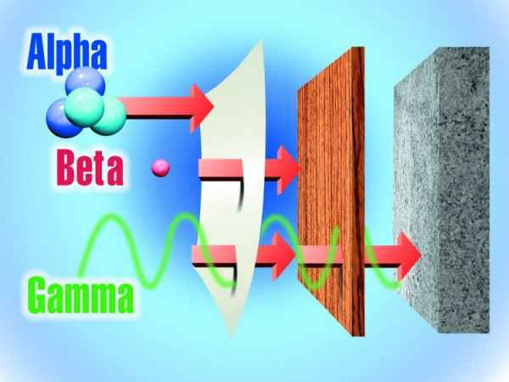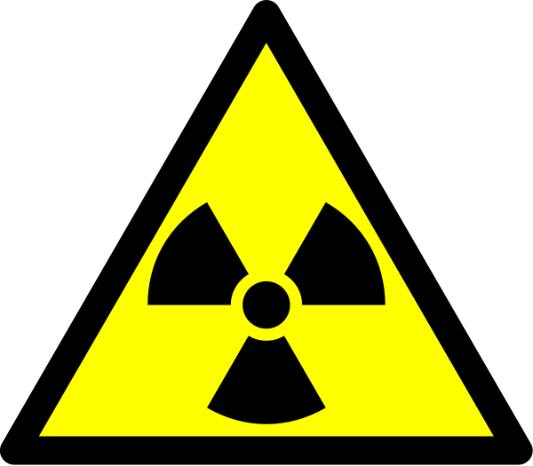

Throughout the Course, appropriate attention should be given to units, prefixes and scientific notation.

|  |  |  |  |
| --- | --- | --- | --- |
| Prefix | Symbol | Notation | Operation |
| tera | T | 1012 | x 1,000,000,000,000 |
| giga | G | 109 | x 1,000,000,000 |
| mega | M | 106 | x 1,000,000 |
| kilo | k | 103 | x 1,000 |
| centi | c | 10-2 | /100 |
| milli | m | 10-3 | /1,000 |
| micro | µ | 10-6 | /1,000,000 |
| nano | n | 10-9 | /1,000,000,000 |
| pico | p | 10-12 | /1,000,000,000,000 |

In this section the prefixes you will use most often are milli (m), micro (µ), kilo (k), mega (M) and giga (G). It is essential that you use these correctly in calculations.

In Physics, the standard unit for time is the **second** **(s)** and therefore if time is given in milliseconds (ms) or microseconds (µs) it must be converted to seconds.

Example 1

a) A wave takes 40 ms to pass a point. How many seconds is this?

40 ms = 40 milliseconds = 40 x 10-3 s = 40/1 000 = 0.040 seconds.

b) A faster wave travels past in a time of 852 µs, how many seconds is this?

852 µs = 852 microseconds = 852 x 10-6 s = 852/1 000 000 = 0.000852 seconds.

In Physics, the standard unit for distance is the **metre** **(m)** and therefore if distance is given in kilometres (km) it must be converted to metres.

Example 2

A wave travels 26.1 km in 0.5 ms. How far in metres has it travelled?

26.1 km = 26.1 kilometres = 26.1 x 103 m = 26.1 x 1 000 = 26 100 metres.

This unit involves calculations which use the term frequency, frequency has units of **hertz** (Hz) although often we meet the terms Megahertz and Gigahertz.

Example 3

A wave has a frequency of 99.5 MHz. How many Hz is this?

99.5 MHz = 99.5 Megahertz = 99.5 x 106 Hz = 99.5 x 1 000 000 = 99 500 000 Hertz.

**S3 and S4 Physics**

**Radiation**

Contents

[The nature of Nuclear radiations 5](#_Toc368228342)

[Atoms 5](#_Toc368228343)

[Nuclear Radiation (Alpha, Beta And Gamma) 6](#_Toc368228345)

[Alpha particles α 6](#_Toc368228346)

[Beta particles β 6](#_Toc368228347)

[Gamma rays γ 6](#_Toc368228348)

[Ionising effect of Nuclear Radiation 7](#_Toc368228349)

[Ionisation 7](#_Toc368228350)

[Penetrating ability and Absorption 7](#_Toc368228351)

[Sources of Nuclear Radiation 8](#_Toc368228353)

[Natural Sources 8](#_Toc368228354)

[Dosimetry 9](#_Toc368228355)

[Absorbed Dose (D) 9](#_Toc368228356)

[Equivalent Dose (H) 9](#_Toc368228357)

[Radiation Weighting Factor (ωR) 9](#_Toc368228358)

[Equivalent Dose Rate 10](#_Toc368228359)

[Dose from natural background radiation 11](#_Toc368228360)

[Dose from artificial background radiation 12](#_Toc368228365)

[Industrial Uses of Nuclear Radiation 13](#_Toc368228369)

[Activity 14](#_Toc368228374)

[Background Activity 14](#_Toc368228375)

[Measuring Activity 14](#_Toc368228376)

[Half-life (t1/2) 15](#_Toc368228377)

[Corrected count rate 15](#_Toc368228378)

[Nuclear Fission and Fusion 17](#_Toc368228379)

[Nuclear Power Stations 17](#_Toc368228380)

[Nuclear Fission 18](#_Toc368228381)

[The Nuclear Reactor 20](#_Toc368228382)

[Radioactive Waste 21](#_Toc368228383)

[Nuclear Fusion 22](#_Toc368228384)

**Nuclear radiation**

* 1. The nature of alpha, beta and gamma radiation: relative effect of ionisation, absorption, shielding.
  2. Background radiation sources.
  3. Absorbed dose, equivalent dose and comparison of equivalent dose due to a variety of natural and artificial sources.
  4. Applications of nuclear radiation.
  5. Activity in Becquerels.
  6. Half-life and use of graphical or numerical data to determine the half-life.
  7. A qualitative description of fission and fusion, emphasising the importance of these processes in the generation of energy.

$$D = \frac{E}{m}$$

$$H = D ω_{R}$$

$$\dot{H}= \frac{H}{t}$$

$$A = \frac{N}{t}$$

# The nature of Nuclear radiations

### Atoms

Every substance is made up of atoms.

Atoms are the smallest possible particle of the simple substances (the elements – see periodic table) that make up everything around us. Each element is made up of the one kind of atom. All atoms of one element are identical to one another, but they are different to atoms of other elements. This is because they are made from different combinations of **electrons, protons and neutrons.**

Inside each atom there is a small dense central part called the nucleus. The nucleus contains two particles:

* **protons**: these have a positive charge
* **neutrons**: these have no charge.

Together protons and neutrons are called **nucleons.**

Surrounding the nucleus are negatively charged **electrons.** The electrons go round the nucleus in orbits. An **uncharged** atom will have the same number of protons and electrons. Sometimes different atoms are combined together to form compounds.

### Example - Helium

This has two neutrons and two protons in the nucleus, and as it is uncharged there will be two electrons orbiting the nucleus.

This can be represented as:

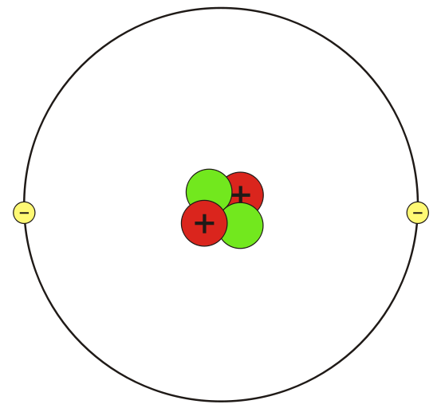

Nucleus

Nucleons

Neutron

Proton

Electron

## Nuclear Radiation (Alpha, Beta And Gamma)

There are some atoms which have unstable nuclei. (*Nuclei is the plural of nucleus).*

Everything in nature prefers to be in a stable state of minimum energy. The unstable nuclei are unstable because they have too much energy. They get rid of this energy by emitting some form of radiation (either particles or electromagnetic waves). This radiation is **nuclear radiation** because it comes from the **nucleus** of an atom. These atoms are said to be **radioactive**.

There are three types of nuclear radiation:

* α (alpha) particles
* β (beta) particles
* γ (gamma) rays

When α, β or γ are emitted from the nucleus energy is also released. This energy is usually absorbed by the medium through which the radiation is passing.

### Alpha particles α

They consist of 2 neutrons and 2 protons and are therefore positively charged with a charge of +2e (where e is the size of the charge on an electron, i.e 1.6x10-19 C). So theyhave the same structure as the nucleus of a helium atom.

Symbol: ${}_{2}^{4}α$

 

### Beta particles β

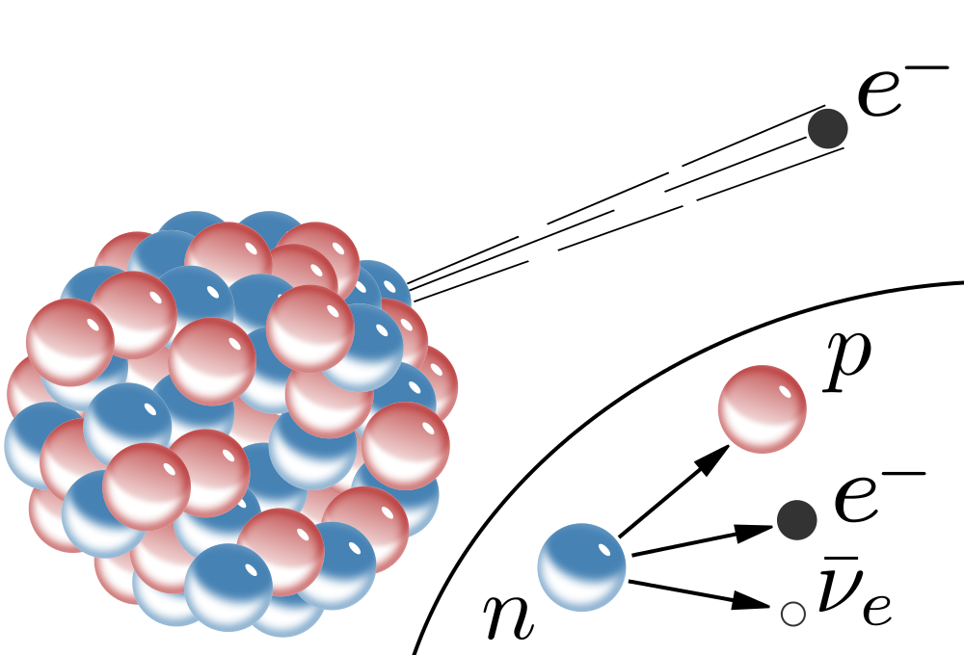

They are fast moving electrons with a charge of -1e. Note that they come **from the nucleus** of an atom. They are caused by the break up of a neutron into a positively charged proton and a negatively charged electron.

Symbol: ${}_{-1}^{0}β$

### Gamma rays γ

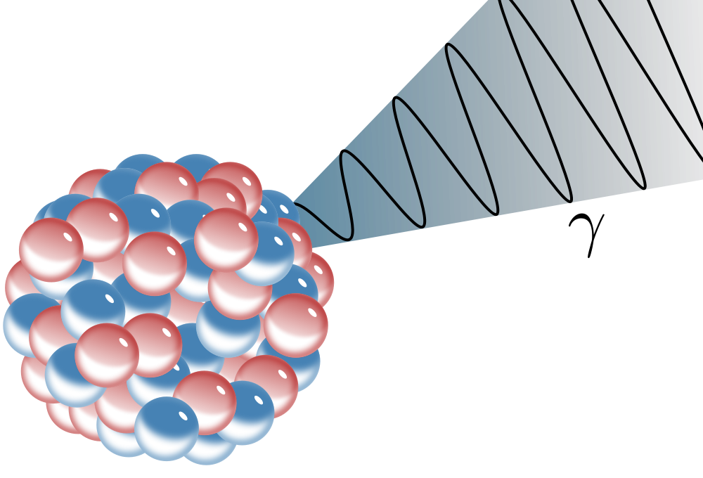Theyare caused by energy changes in the nucleus. Gamma rays are high frequency waves which are part of the electromagnetic spectrum.

Often the gamma rays are sent out at the same time as alpha or beta particles. Gamma rays have neither mass nor charge but carry energy from the nucleus leaving the nucleus in a more stable state.

Symbol:γ

## Ionising effect of Nuclear Radiation

### Ionisation

If the number of electrons is equal to the number of protons then the **Atom** is uncharged and is electrically neutral.

However, atoms can gain or lose electrons, this increases or decreases the negative charge.

* Ionisation is the addition or removal of an electron from an **Atom** to create an **Ion**.
* Losing an electron creates a **Positive Ion**.
* Gaining an electron creates a **Negative Ion**.

Alpha or beta particles are charged. When they pass nearby other atoms they tend to cause it to lose electrons so that it becomes ionised. Gamma rays do not directly ionise other atoms, although they may cause atoms to emit other particles which will then cause ionisation. As a result, nuclear radiation is sometimes **Ionising** Radiation.

Because of the differences in the charges they carry, the ionising effect of the three types of nuclear radiation is different.

* α particles: highly ionising
* β particles: ionising
* γ rays: very weakly ionising

### Penetrating ability and Absorption

The penetrating ability and ionising ability of nuclear radiation are linked. The radiation continues to penetrate matter until it has dissipated all of its energy.

Alpha particles are the least penetrating, as they are the most highly ionising. They are absorbed by 10 cm of air; 0.01 mm lead or a sheet of paper. This means that if a given number of alphas are fired at a target they will all cause ionisation near the surface of the material, resulting in the effects of the radiation being concentrated in a small volume. The double charge and relatively high mass of the alpha explains why the impact on matter is so great.

Beta particles can penetrate quite deeply into matter before its energy has been absorbed. Its penetrating power is therefore moderate (absorbed by 1m air, 0.1 mm lead or 3mm aluminium sheet). Beta particles have only about 1/8000 of the mass of an alpha particle and only half of the charge. Therefore its interaction with matter as it passes through is far less severe and so the effects of its interaction (ionisation) are much more spread out.

Gamma Rays have an ionising ability so low that they penetrate very deeply into matter before most of the energy has been absorbed. Their penetrating ability is therefore very high (about 99.9% is absorbed by 1 km of air or 10 cm lead). Gamma rays are pure energy - no charge and no mass - therefore their interaction with matter is much less than the other two.

## Summary of nuclear radiation properties

|  |  |  |  |
| --- | --- | --- | --- |
|  | Alpha particle | Beta  particle | Gamma  ray |
| Mass *(amu)* | 4 | 1/2000 | 0 |
| Charge | +2e | -1e | 0 |
| Speed | slow | fast (almost speed of light) | very fast (speed of light) |
| Ionising ability | high | medium | 0 |
| Penetrating power | low | medium | high |
| Stopped by: | paper | aluminium | lead |

1 amu = 1 atomic mass unit (1.66 x 10-27 kg): 1 e = electron charge (1.6x10-19 C)

## Sources of Nuclear Radiation

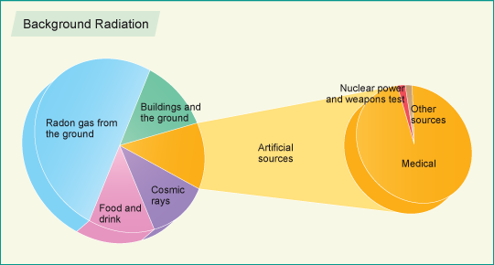Nuclear radiation is a naturally occurring phenomenon and so the sources of this radiation are all around us. This is known as **Background Radiation.**

Background radiation is made up of natural and artificial (man-made) sources. The majority of the background is natural. Artificial sources of background account for about 15% of the total and most of this comes from medical examinations, such as X-rays and other scans.

### Natural Sources

Naturally occurring nuclear radiation comes from radioactive substances including the ground, the air, building materials and food. Radiation is also found in the cosmic rays from space.

|  |  |
| --- | --- |
| Source | Type of Radiation |
| Cosmic Rays | Radiation that reaches the Earth from outer space |
| Animals | All animals emit natural levels of radiation |
| Rocks | Some rocks give off radioactive radon gas |
| Soil and Plants | Radioactive materials from rocks in the ground are absorbed by the soil and hence passed on to plants |

## Dosimetry

### Absorbed Dose (D)

Damage can be done to the body due to the energy absorbed from nuclear radiation as it penetrates the body.

The greater the absorbed energy, the greater the damage is likely to be. The absorbed dose, D, is defined as the energy absorbed per unit mass of the absorbing material

$$D = \frac{E}{m}$$

### Equivalent Dose (H)

As we have seen above, the different types of nuclear radiation have different penetrating and ionising powers. In order to compare the effects of the same absorbed dose but with different radiation types it is necessary to weight these differing penetrating and ionising powers. This is done using a number known as Radiation **Weighting Factor (ωR).** The radiation weighting factoris simply a scale factor, which indicates the ability of a particular type of radiation to cause damage.

|  |  |  |  |
| --- | --- | --- | --- |
| Symbol | Name | Unit | Unit Symbol |
| D | Absorbed dose | gray | G |
| E | Energy absorbed | joule | J |
| m | Mass | kilogram | kg |

Equivalent Dose, H, combines the Absorbed Dose information with the Radiation Weighting Factorto give a more accurate “picture” of the potential harm that could be done by radiation using the equation.

|  |  |  |  |
| --- | --- | --- | --- |
| Symbol | Name | Unit | Unit Symbol |
| D | Absorbed dose | gray | G |
| H | Equivalent dose | sievert | Sv |
| ω**R** | Weighting Factor | n/a |  |

|  |  |
| --- | --- |
| Radiation Type | ωR |
| X-rays | 1 |
| γ rays | 1 |
| β particles | 1 |
| thermal neutrons | 3 |
| fast neutrons | 10 |
| α particles | 20 |

### Radiation Weighting Factor (ωR)

Do not forget that biological harm from exposure to radiation depends on:

* the absorbed dose
* the kind of radiation (e.g. α particles are highly ionising)

These two are combined in the Equivalent Dose value in Sieverts.

The overall biological effect must also take account of the body organs or tissues exposed.

### Equivalent Dose Rate

The time of exposure (t) to ionising radiation is also important. An equivalent dose of 100 mSv received in one day is more dangerous than the same equivalent dose received over the course of one year.

The equivalent dose rate is defined by the equation

$$\dot{H}= \frac{H}{t}$$

|  |  |  |  |
| --- | --- | --- | --- |
| Symbol | Name | Unit | Unit Symbol |
| H | Equivalent dose | sievert | G |
| H | Equivalent dose rate | sievert per second | Sv/s |
| t | Time of exposure | seconds | S |

Equivalent dose rate can be quoted in a variety of units -sieverts/millisieverts/microsieverts per second/minute/hour. Make sure that the units you use in any problem are consistent.

## Dose from natural background radiation

Radiation has always been present all around us. In fact, life has evolved in a world containing significant levels of ionising radiation. It comes from space, the ground, and even within our bodies. The doses due to natural background radiation vary depending on location and habits.

### Dose from cosmic radiation

Regions at higher altitudes receive more cosmic radiation. The worldwide annual average equivalent dose from cosmic rays is about 0.40 mSv, although this varies from 0.30 mSv (sea level) to 0.84 mSv at the top of Mount Lorne, Yukon (2000 m). Air travel also increases exposure to more cosmic radiation, adding a further average annual dose of 0.018 mSv per person in the developed world.

### Dose from terrestrial radiation

There are also natural sources of radiation in the ground. The worldwide average effective dose from the radiation emitted from the soil (and other materials that come from the ground) is approximately 0.5 mSv a year. However, the dose varies depending on location and geology, with doses reaching as high as 260 mSv in Northern Iran or 90 mSv in Nigeria.

### Dose from inhalation

Radon gas, which is produced by the earth, is present in the air we breathe. Radon gas naturally disperses as it enters the atmosphere from the ground. However, when radon gas enters a building (through the floor from the ground), the concentration tends to build up. The worldwide average annual effective dose of radon radiation is approximately 1.2 mSv.

### Dose from ingestion

There are a number of sources of natural radiation that penetrate our bodies through the food we eat, the air we breathe and the water we drink. Potassium-40 is the main source of internal irradiation (found in Brazil nuts, Lima Beans, Bananas, Carrots, Potatoes, Lo-Sodium Salt). The worldwide average effective dose from these sources is approximately 0.3 mSv a year.

## Dose from artificial background radiation

Most artificial sources are related to medical procedures. The table shows the absorbed doses involved. Notice that the highly medically effective procedures such as CT scanning come at a “cost” of radiation exposure.

|  |  |
| --- | --- |
| Study Type | Dose (mSv) |
| Dental X-ray | 0.01 |
| Chest X-ray | 0.1 |
| Screening mammography | 3 |
| Adult abdominal CT | 10 |
| Neonatal abdominal CT | 20 |

Nuclear weapon testing, the Chernobyl disaster and Nuclear Power generation add a further 7.2 μSv to the worldwide average equivalent dose.

### Medical Uses of Nuclear Radiation[[1]](#footnote-1)

It can be seen from the annual equivalent dose numbers above that the primary source of artificial nuclear radiation is in medicine — for diagnosis and therapy. Both are intended to benefit patients and, as with any use of radiation, the benefit must outweigh the risk.

### Diagnosis

Most people at some time in their lives have an X ray examination to help diagnose disease or damage in the body. A much less common diagnostic procedure involves the introduction of radionuclides inside patients so that detectors outside the body can be used to observe how organs are functioning. Radiation doses are generally low, although they can be appreciable in certain procedures.

### Therapy3

Much higher doses are required to treat malignant diseases or malfunctioning organs sometimes in combination with other forms of treatment.

* **outside the body** (external radiotherapy) - using X-rays, electrons or, in rare cases, other particles such as protons; external radiotherapy is usually given once a day as a course of treatment over a number of days or weeks
* **within the body** (internal radiotherapy, also known as brachytherapy) - either by drinking a liquid that is absorbed by the cancerous cells or by putting radioactive material into, or close to, the tumour, usually for a small number of treatments (brachytherapy) or by injecting or drinking a liquid that is absorbed by the cancerous cells - for example, radioiodine for thyroid cancer.

## Industrial Uses of Nuclear Radiation

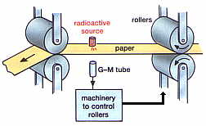In industry, radiation is used in quality control of materials, measuring the level of containers, or monitoring the thickness or consistency of paper, for example. Devices which monitor industrial processes consist of radiation sources and detectors. When the material between the radioactive source and the detector changes thickness or density, the level of radiation detected also changes. The process can be controlled by weakening or strengthening the signal from the detector.

### Radiography

This is a method of non-destructive testing, used to check for flaws in metal structures and welding seals, among others. The principle is the same as in medical imaging: radiation passes through the object to be tested and exposes the X-ray film placed behind it. Dark patches in the developed film reveal flaws. Radiography devices create radiation using either X-ray machines, or for thicker material, a gamma source or linear accelerator.

### Tracers

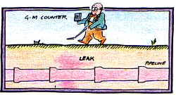Radioactive isotopes are used as tracers in many biochemical and physical examinations. The path of material marked with radioactive tracers is monitored with a detector. Radioactive isotopes of carbon and hydrogen can be used to examine the path of nutrients into plants, for example. Also radioisotopes are used to detect leaking pipes. To do this, a small amount of a gamma emitter is injected into the pipe. The radiation is then detected with a GM counter above ground.

### Sterilisation

Gamma rays can be used to kill bacteria, mould and insects in food. This process prolongs the shelf life of the food, but sometimes changes the taste. Gamma rays are also used to sterilise hospital equipment, especially plastic syringes that would be damaged if heated.

### Dating

Because the radioactive half-life of a given radioisotope is not affected by the environment radioactive samples continue to decay at a predictable rate, i.e. any radioactive nucleus acts as a clock. Organic materials may be dated using Carbon-14 content whilst longer-lived isotopes in rocks and minerals provide evidence of long timescales in geological processes.

## Activity

Some materials are radioactive because their nuclei are unstable. It is impossible to tell when a particular nucleus will break apart. What we can measure is the number of nuclei (N) in a quantity of a radioactive substance that will decay in a particular time (t). The activity of any radioactive substance is the rate at which it decays and is defined by the equation

$$A = \frac{N}{t}$$

|  |  |  |  |
| --- | --- | --- | --- |
| Symbol | Name | Unit | Unit Symbol |
| A | Activity | becquerel | Bq |
| N | Total count | n/a |  |
| t | Time | second | s |

Activity is measured in becquerel (Bq) where one Bq is one nucleus decaying every second. Activity relates to a quantity of a radioactive substance. It is meaningless to refer to the 'activity of uranium oxide' for example, since the activity depends on how much of the substance is present. Radioactive decay happens spontaneously. The number of nuclei in a quantity of radioactive substance still to decay depends on how many have already decayed. Because of these factors, activity is not constant over time.

### Background Activity

Radiation from natural sources and man made sources are around us all the time. This is called Background Activity - it's very low level, usually less than 1 Bq. However, if you were to measure the activity of a source, you would also be measuring the background activity. To ensure that you calculate the correct activity for a source, the average background activity must first be measured and then deducted from the measured activity.

### Measuring Activity

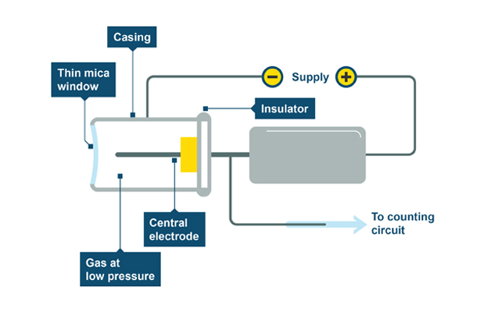The ionising effect of radiation is used in the Geiger-Muller (GM) tube as a means of detecting the radiation. The GM tube is a hollow cylinder filled with a gas at low pressure. The tube has a thin window made of mica at one end. There is a central electrode inside the GM tube. A voltage supply is connected across the casing of the tube and the central electrode as shown in the following diagram. When nuclear radiation enters the tube it produces ions in the gas allowing it to conduct which produces a voltage pulse. Each voltage pulse corresponds to one ionising radiation entering the GM tube. The voltage pulse is amplified and counted. The greater the amount of radiation, the more ionisation in the tube so the greater the rate of counts. The activity of a substance is the number of counts or ionisations per second.

## Half-life (t1/2)

Radioactive decay involves a change from a high energy state to a lower energy state for the individual atoms involved. As a result of decay then there are fewer high energy, radioactive atoms. This means the overall activity will decrease over time as fewer candidate atoms are available to decay.

Radioactive decay is a random process. This means that for a radioactive source, it is not possible to predict when an atom will decay. Each atom has an equal probability to be the next atom to decay. In any radioactive source, the activity decreases with time because the number of unstable atoms gradually decreases leaving fewer atoms to decay.

The **half-life** of a radioactive source is **the time for the activity to fall to half** **its original value**. Half-life is measured in units of time. This may be seconds, minutes, days or years.

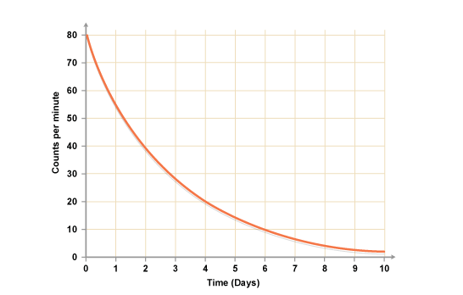

Using a graph of activity versus time, it is possible to calculate the half-life of a radioactive source.

The count rate drops from 80 to 40 in two days. In the next two days, it drops from 40 to 20 - it halves. In the two days after that, it drops from 20 to 10 - it halves again - and so on. So the half life,

t1/2 = 2 days

t½  should be the same value no matter which starting activity is selected.

### Corrected count rate

When making accurate measurements of the decay of a radioactive source you must always use the corrected count rate. This is the count rate that is due to the source alone and not including any background radiation.

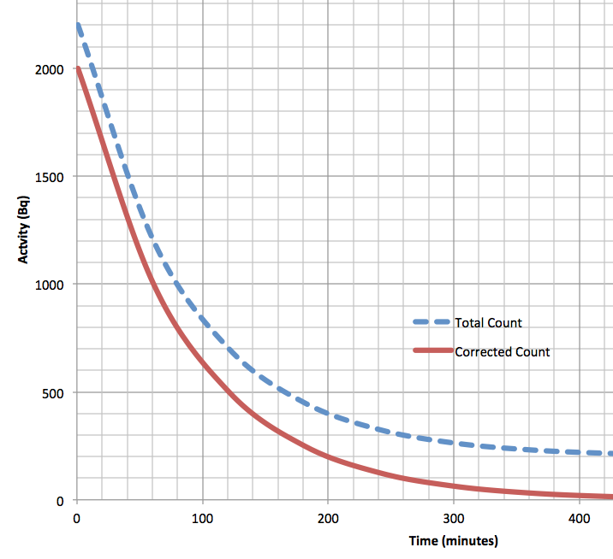

t1/2

From the diagram it can be seen that incorrectly using the total count curve gives an erroneously large value for t1/2

corrected count = total count – average background count

Examples

1. A Geiger-Muller tube and ratemeter were used to measure the half-life of radioactive caesium-140. The activity of the source was noted every 60 s. The results are shown in the table. By plotting a suitable graph, find the half-life of caesium-140.

|  |  |  |  |  |  |  |  |
| --- | --- | --- | --- | --- | --- | --- | --- |
| Time (s) | 0 | 60 | 120 | 180 | 240 | 300 | 360 |
| Corrected count rate (counts/s) | 70 | 50 | 35 | 25 | 20 | 15 | 10 |

From ***the best-fit line*** on the graph the time taken to fall from

* 70 counts/s to 35 counts/s = 125 s
* 35 counts/s to 17.5 counts/s = 125 s

Average half-life of caesium-140 = 125 s.

1. The activity of a source falls from 80 MBq to 5 MBq in 8 days. Calculate its half-life.

|  |  |
| --- | --- |
| Count Rate (MBq) | Number of t1/2 |
| 80 | 0 |
| 40 | 1 |
| 20 | 2 |
| 10 | 3 |
| 5 | 4 |

There are 4 x t1/2 in 8 days. Therefore t1/2 = 8/4 = 2 days

**Or**

80 40 20 10 5

This takes 4 half-lives (count the arrows) = 8 days.  
So one half-life, t1/2 = 8/4 = 2 days

## Nuclear Fission and Fusion

### Nuclear Power Stations

A nuclear power station is similar to a coal or oil fired power station, but the fuel used to produce the heat is uranium or plutonium. The particles (or atoms) of the uranium or plutonium are spilt into smaller particles in a nuclear reactor.

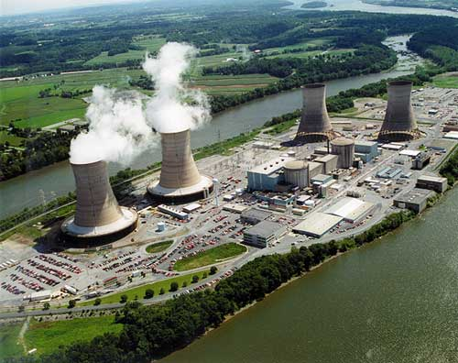

This is called FISSION**.** *(See later notes).*

When the atoms split a large amount of heat is produced, which is used to turn water into steam. In turn the steam is used to spin a turbine, which turns a generator to produce electricity.

Although nuclear power stations can produce large amounts of electricity, with no further use of fossil fuels there are other dangers involved.

**Advantages of Using Nuclear Power to Produce Electricity**

* Fossil fuels are running out, so nuclear power provides a convenient way of producing electricity.
* A nuclear power station needs very little fuel compared with a coal or oil-fired power station. A tonne of uranium gives as much energy as 25000 tonnes of coal.
* Unlike fossil fuels, nuclear fuel does not release large quantities of greenhouse gases or sulphur dioxide (a cause of acid rain) into the atmosphere.
* A country may not want to be reliant on imports of fossil fuels. If a country has no fossil fuels of its own it might use nuclear power for security reasons.

**Disadvantages of Using Nuclear Power to Produce Electricity**

* A serious accident in a nuclear power station is a major disaster. British nuclear reactors cannot blow up like a nuclear bomb but even a conventional explosion can possibly release tonnes of radioactive materials into the atmosphere. (The Chernobyl disaster was an example of a serious accident.)
* Nuclear power stations produce radioactive waste, some of which is very difficult to deal with. Nobody wants radioactive waste stored near them.
* After a few decades nuclear power stations themselves will have to be decommissioned.

### Nuclear Fission

Nuclear fission is the process in which one nucleus splits into more than one nuclei, leading to formation of other elements and the release of energy in the process. There are two types of nuclear fission: spontaneous and stimulated fission. Some heavy nuclei are not stable so they will undergo **spontaneous fission** and give lighter nuclei.

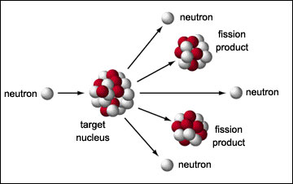

Uranium

nucleus

Sometimes fission is **stimulated** by collisions with other particles. For example, the fission of uranium 235 in nuclear reactors is started by the collisions with neutrons. If a neutron is fired into the nucleus of a uranium 235 atom, the atom will split into two new nuclei emitting further neutrons and releasing energy in the form of heat (i.e. the kinetic energy of the emitted nuclei).

This splitting of the atom is known as **STIMULATED** **NUCLEAR FISSION. The new nuclei are known as fission fragments.** The emitted neutrons hit other atoms causing them to split.

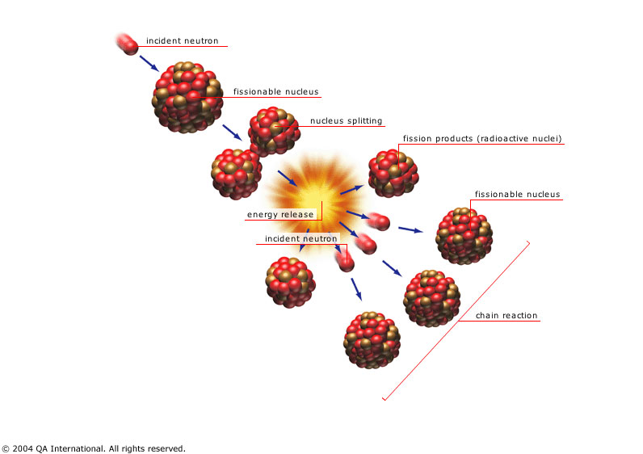

If this process keeps going, a **CHAIN REACTION** results giving out huge amounts of energy in a way which is difficult to control.

In a **nuclear reactor**, the chain reaction is controlled by **control rods** and the **moderator.**

Fission reactions take place only if the neutrons are travelling slow enough to be ‘captured’ by the atom. **Collisions with the moderator** will **slow down** the **fast neutrons** and **allow more fission** to take place. **Control rods** absorb neutrons. This will allow the reactor to produce energy at a steady rate.

In a controlled chain reaction, on average only one neutron from each fission will strike another nucleus and cause further stimulated fission to occur.

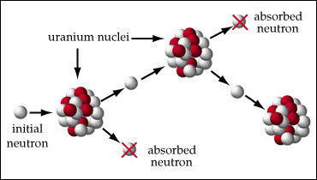

In an uncontrolled chain reaction all the neutrons from each fission strike other nuclei producing a large surge of energy. This occurs in atomic bombs.

## The Nuclear Reactor

There are five main parts of a reactor as shown in the diagram below:

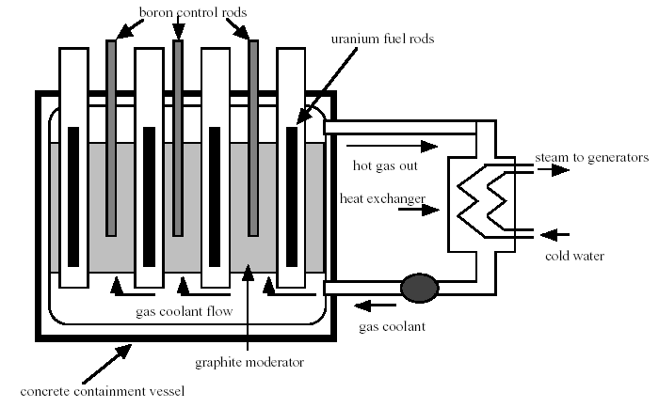

* The **fuel rods** are made of uranium-238 enriched with uranium-235. They release energy by fission.
* The **moderator**, normally made of graphite, has the fuel rods embedded in it. The purpose of the moderator is to **slow down** the neutrons that are produced in fission, since a nucleus is split more easily by slow moving neutrons.
* The **control rods** are normally made of boron, and they control the rate of production of energy. The boron rods **absorb** neutrons, so by lowering the control rods into the reactor, the reaction can be slowed down. In the event of an emergency the control rods are pushed right into the core of the reactor and the chain reaction stops completely.
* A **cooling system** is needed to cool the reactor and to transfer heat to the boilers in order to generate electricity. The diagram shows the original British gas-cooled reactor design which used carbon dioxide gas as a coolant. Other systems have used water and some even use liquid sodium metal as the coolant material.
* The **containment vessel** is made of thick concrete which acts as a shield to absorb neutrons and other types of radiation.

## Radioactive Waste

Nuclear power stations unfortunately produce dangerous radioactive waste materials, some of which have half-lives of hundreds of years.

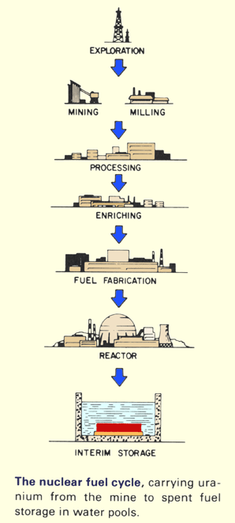

When the used fuel is taken out of the reactor core, all the dangerous waste materials must be safely stored until its radioactivity reaches a safe level.

These waste products are first set in concrete and steel containers then buried deep under ground or dropped to the bottom of the sea.

These types of disposals are very controversial. Some scientists believe the containers will keep the radioactive material safe for a long time; other scientists are worried that the containers will not remain intact for such a long time.

Most recently the British government has decided to dig up radioactive waste buried in the 1960’s near Dounreay in Scotland for fear of radioactive leakage.

There is also the controversial issue of transportation of the waste fuel products. Some towns and cities (there was a sign as you enter Dundee from the north) have declared themselves nuclear free zones.

As a result no trains or lorries can travel within their boundaries if they are transporting nuclear waste. One big question that has never been fully answered is the safety of the waste products whilst they are in transit.

Waste products from nuclear power stations can be reprocessed, but again this is controversial as one of the uses of reprocessed plutonium is weapon grade plutonium which could be used in nuclear weapons.

It is not the remit of this course to take a stand one way or the other on the use of fission reactions in producing energy. For every positive reason there seems to be a convincing negative reason.

### Nuclear Fusion

Where nuclear fission is the splitting of large, heavy nuclei into smaller, lighter fragments nuclear fusion is the process in which the nuclei of light elements combine, or fuse together, to give heavier nuclei.

An example of a fusion reaction is that of two deuterium nuclei fusing together to give a helium nucleus. Deuterium is an isotope of hydrogen (21H). The reaction is as follows:

$${}_{1}^{2}{H +}{}_{1}^{2}{H }→ {}_{2}^{4}{He+energy}$$

Fusion reactions are accompanied by a much greater mass to energy conversion than in fission reactions. Nuclear fusion is difficult to achieve, as it requires extremely high temperatures. This is because the small nuclei are positively charged and therefore repel each other. The high temperature means that they have enough kinetic energy to overcome their electrostatic repulsion.

Nuclear fusion occurs naturally in stars where the gravitational attraction of the large mass making up the star gives rise to such high temperature and pressure that the fusion process becomes possible. So the energy we receive from the sun is from nuclear fusion. Our nearest star, the Sun, is made up mainly of mostly hydrogen and helium. Within the sun the temperature is millions of degrees Celsius, there is the constant fusion of small nuclei into larger nuclei.

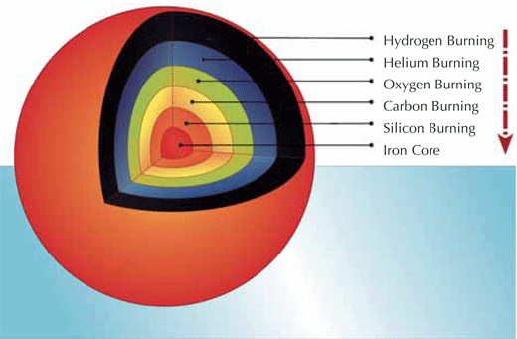The fusion process in stars is the method by which all of the elements in the Universe were formed from the original simple particles present after the Big Bang. This is known as **nucleosynthesis** (the creation of new heavier nuclei from lighter ones) and continues over the star’s life cycle producing heavier and heavier elements. A limit is reached when Iron (26 protons) is produced, as the energy required to fuse elements heavier than Iron is greater than that available from the fusion reaction.

### Man-made Nuclear Fusion

On Earth, attempts have been made to create nuclear fusion reactors for use in electrical power generation but the technology to achieve the extremely high temperatures and pressures is very expensive and difficult to create.

Compared to nuclear fission, nuclear fusion reactors:

* Release even more energy per kg of fuel
* Make less radioactive emissions as many of the products are stable (e.g. 4He)
* Use ‘cleaner’ fuel: isotopes of hydrogen, which can be made from water and lithium

### Magnetic containment: the tokamak

ITER (**International Thermonuclear Experimental Reactor**) is a joint international research and development project that aims to demonstrate the scientific and technical feasibility of fusion power. ITER is being constructed in Europe, at Cadarache in the South of France.

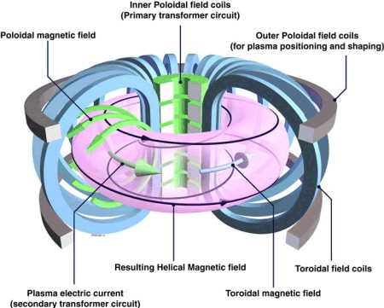 ITER will use the reaction between two hydrogen (H) isotopes: deuterium (D, ${}_{1}^{2}H$) and tritium (T, ${}_{1}^{3}H$). The D-T fusion reaction produces the highest energy gain at the 'lowest' temperatures. It requires nonetheless temperatures of 150,000,000° C to take place - ten times higher than the H-H reaction occurring at the Sun's core. At these extreme temperatures, electrons are separated from nuclei and a gas becomes a **plasma -** a hot, electrically charged gas. In a star as in a fusion device, plasmas provide the environment in which light elements can fuse and yield energy. In ITER, the fusion reaction will be achieved in a **tokamak** device that uses magnetic fields to contain the charged particles of the plasma in a doughnut shaped ring inside a vacuum chamber.

The fusion between deuterium and tritium (D-T) will produce one helium nuclei, one neutron, and energy.

$${}_{1}^{2}{H +}{}_{1}^{3}{H }→ {}_{2}^{4}{He+ {}_{0}^{1}{n+}energy}$$

The helium nucleus is electrically charged and so will remain confined within the plasma by magnetic fields of the tokamak. Around 80% of the energy liberated by the fusion is carried as kinetic energy of the neutron. As this is electrically neutral its travel is unaffected by magnetic fields and so these neutrons will be absorbed by the surrounding walls of the tokamak, transferring their energy to the walls as heat.

### life_target_482x618Inertial Confinement Fusion:

Researchers in the US are trialling a different system called Inertial Confinement Fusion (ICF) which uses small pellets of hydrogen fuel in lithium cases. Intensely powerful LASERs are focused on the pellets, starting a fusion reaction. These are in effect tiny nuclear fusion bombs. A continuous series of pellets would be detonated, with the heat produced being used to produce electricity.

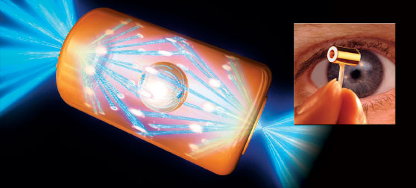

The reactor chamber in ICF is called a hohlraum – a hollow area or cavity – which contains the tiny, 2mm diameter fuel pellets. Once illuminated by the proposed 192 laser beams concentrated onto the target fuel pellet is compressed and heated to ignition temperature within 20 billionths of a second.

**To date continuous controlled fusion in a reactor has still not been achieved !**

1. <http://www.iaea.org/Publications/Booklets/RadPeopleEnv/index.html>

   3 <http://www.nhs.uk/conditions/Radiotherapy/Pages/Introduction.aspx> [↑](#footnote-ref-1)