S1 Energy Homework 4
Name: ______________ Parent/Guardian Signature:
Due date: ___________ ____________________

Instruments of the Symphony Orchestra

- The instruments have been split up into 3 groups.
The instruments in each group all make sound in the same way.
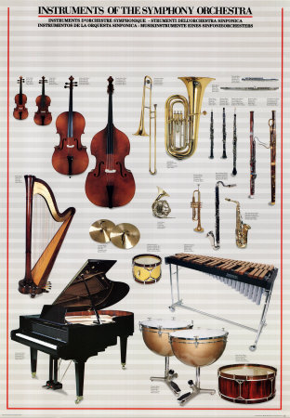
Group 1
Group 2
Group 3
Explain how sound is made in each group by completing the sentences using words or phrases from the box below:

1. In Group 1 you ____________________and the string ________ to make the sound.

2. In Group 2 you ____________________and the air __________ to make the sound.

3. In Group 3 you ____________________and the object _______ to make the sound.

hit an object blow over a column of air pluck the strings
vibrates vibrates vibrates (6)

- A scientist measured how fast sound travelled through air, water, steel and wood. She got the following results:

Material Speed of travel of sound

Air 350 metres per second
Water 1500 metres per second
Steel 5000 metres per second
Wood 4000 metres per second

- On the back of this homework sheet draw a fully labelled bar chart to show her results. (use a ruler, label the axes, label each bar) (3)

- The three states of matter are:

Solids, Liquids and Gases.

Using the information from the table above, circle the one in which you think sound travels slowest. (1)

