S1 Energy Homework 2
Name: ______________ Parent/Guardian Signature:
Due date: ___________ ____________________

Sally put a solar panel onto the roof of her house. The solar panel changed light energy from the sun into electrical energy, The voltage output (V) is a measure of how much electrical energy is produced.

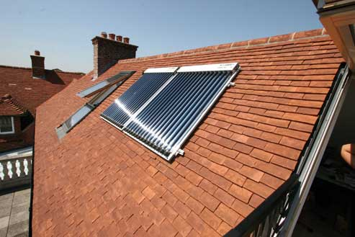

She measured the voltage output (V) at different times of the day and made a graph. The graph is shown below:

Graph Showing Solar Panel Output

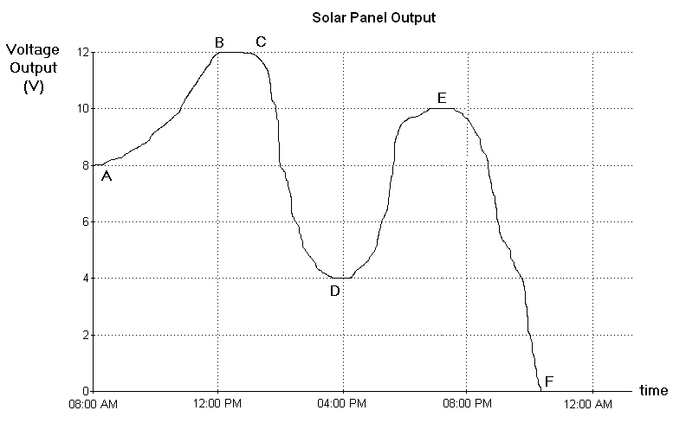

Use the graph to answer questions 1-4.

1. The highest voltage output (V) during the day was ______V.
[1]
2. The voltage output at 08:00AM was ______V. [1]

3. Circle the correct letter:

The voltage output is 4V at A B C D E F
The voltage output is 10V at A B C D E F
[2]

4. The sun sets between which 2 letters? ___ and ___ .
[2]

5. During a weather forecast Sally finds out that it may become cloudy in the afternoon. Was the forecast right?
Use the information from the graph and cross out the wrong words in the boxes:

Yes right
No the forecast was wrong .

From 1pm till 4pm the voltage output increased
decreased .

This was because the amount of sunlight increased
decreased . [2]

