Knox Academy Physics Department

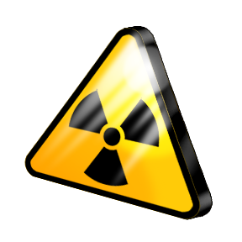
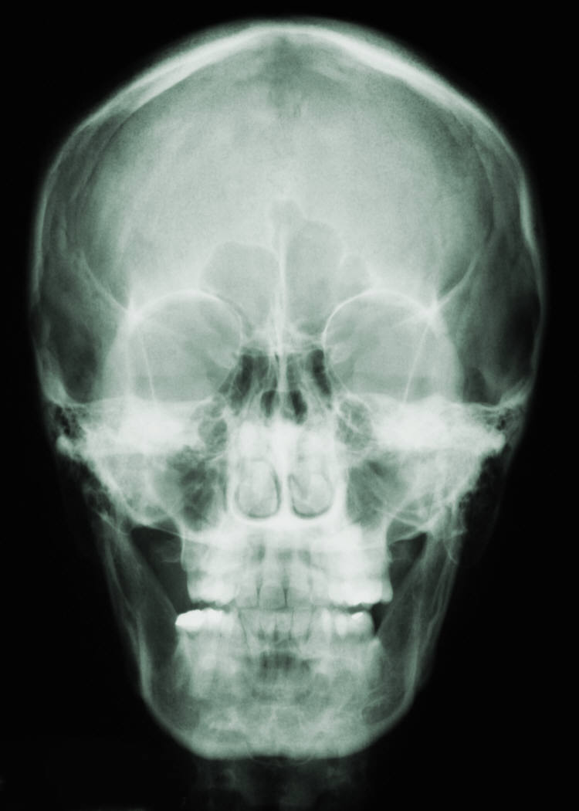

S3 & S4 Physics
Waves & Radiation

Problem Booklet

Contents

Topic | Page
Wave Properties | 4
Wave Speed | 5
Wave Equation | 6
Sound | 7 - 8
Electromagnetic Spectrum | 9 - 10
Diffraction | 11
Refraction | 12 - 15
Properties of Radiation | 16 - 17
Activity | 18 - 19
Half Life | 20 - 21
Absorbed Dose | 22
Equivalent Dose | 23 - 25
Nuclear Fission and Fusion | 26

Wave Properties

- Copy and complete this sentence:

_______________ can be transferred from one place to another as waves.

- What is the meaning of the term ‘transverse’ when describing waves?

- What is the meaning of the term ‘longitudinal’ when describing waves?

- Copy this diagram of a wave and label the following:

Wavelength, Amplitude, Crest, Trough, Axis

- Describe the following properties of waves.

- Wavelength
- Frequency
- Amplitude
- Wave speed

- Water waves are represented in these diagrams. Calculate the wavelength and amplitude of each wave.
(a)
12 m
2 m
(b)
20 m
6 m

(c)
5 m
1.5 m
(d)
30 m
5.5 m

Wave Speed

Useful Equation:
v
=
t
d
v
d
t

where: v is the speed of a wave (m s⁻¹)
d is distance travelled by a wave (m)
t is the time taken by a wave to travel a distance (s)

- Copy and complete this table:

 | Speed / m s⁻¹ | Distance / m | Time / s
(a) |  | 50 | 20
(b) |  | 280 | 1120
(c) | 12 |  | 0.8
(d) | 340 |  | 3.5
(e) | 6.8 | 272
(f) | 95 | 475

- A water wave travels along the length of a 25 metre swimming pool in 6.25 seconds. What is the speed of the water wave?

- A wave moves along a slinky with a speed of 0.75 m s⁻¹. The wave travels the full length of the slinky in 3.2 seconds. How long is the slinky?

- A seismic wave travels through the ground at 2.5 km s⁻¹ after an earthquake. How long does it take the wave to travel 45 km?
Wave Equation

Useful Equation:
v = f λ
f
v
λ

where: v is the speed of a wave (m s⁻¹)
f is the frequency of a wave (Hz)
λ is the wavelength of a wave (m)

- Copy and complete this table:

 | Speed / m s⁻¹ | Frequency / Hz | Wavelength / m
(a) |  | 800 | 4
(b) |  | 40 000 | 0.0085
(c) | 5 |  | 0.25
(d) | 690 |  | 2.3
(e) | 45 | 15
(f) | 180 | 750

- What is the speed of a water wave that has a frequency of 0.5 Hz and a wavelength of 3.6 metres?

- A wave moving through water has a speed of 2.8 m s⁻¹and a wavelength of 7.0 cm. What is the frequency of the wave?

- A sound wave of frequency 8.5 kHz has a speed of 340 m s⁻¹ in air. What is the wavelength of the wave?
Sound

- Describe how you would measure the speed of sound in air using the following equipment:

An electronic timer, 2 microphones, a metre stick, a bottle and a knife.

- (a) How far will a sound wave travel through air in 5 seconds?

- The sound wave has a frequency of 800 Hz. What is it’s wavelength?

- An ultrasound sound wave from a dolphin travels through water with a wavelength of 3 cm. The wave travels a distance of 150 metres to a second dolphin.

- How long does it take the ultrasound wave to reach the second dolphin?

- What is the frequency of the ultrasound wave?

- A car is fitted with a parking system. This warns how close objects are behind the car. Equipment on the back of the car sends out ultrasound waves and receives the reflected waves.

There is a 5 ms gap between a wave been transmitted and received. How far away is a wall from the back of the car?
- In a classroom experiment, a student is trying to find out the speed of sound through a liquid. The student measures the time taken for a sound wave to travel through different lengths through the liquid. The results are shown in the table.

Distance / m | Time / ms
0.50 | 0.26
1.00 | 0.53
1.50 | 0.79
2.00 | 1.05
2.50 | 1.32
3.00 | 1.58

- Draw a line graph of the results, and use the gradient of the straight line to calculate the speed of sound through the liquid.

- What liquid is the sound travelling through?

- A spectator at a firework display sees a firework explode in the sky and hears the bang 1.5 seconds later.
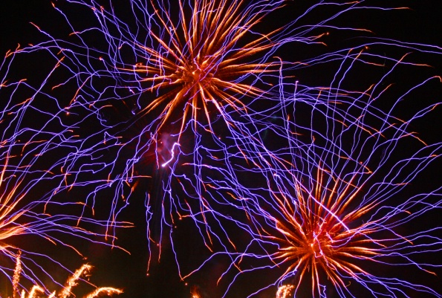

- Explain why there is a delay between seeing the firework explode and hearing the bang?

- How far away is the firework from the spectator when it explodes?

Electromagnetic Spectrum

- The parts of the electromagnetic spectrum are shown below.
Gamma Rays
Infrared Radiation
Visible Light
X-Rays
Radio Waves
Ultraviolet Radiation

Microwaves

Rearrange these electromagnetic waves so that they are in order of increasing frequency.

- What is the speed of an electromagnetic wave in a vacuum?

- What happens to the wavelength of electromagnetic waves as frequency increases?

- What happens to the energy of an electromagnetic wave as frequency increases?

- Describe an application of each of these types of electromagnetic radiation in medicine:
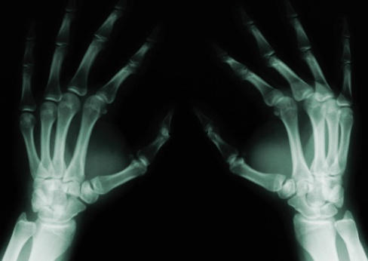
- X-Rays.

- Gamma Rays.

- Infrared Radiation.

- Ultraviolet Radiation.

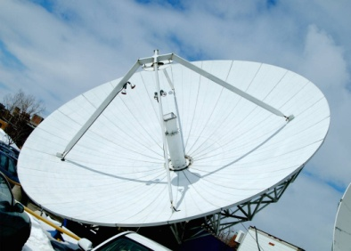
- Describe an application of each of these types of electromagnetic radiation in telecommunication:
- Radio waves.

- Microwaves.

- Describe an application of each of these types of electromagnetic radiation in the home:
- Infrared Radiation.
- Microwaves.

- Why are gamma rays unsuitable for using in mobile phone communication? Give two reasons for your answer.

- How long will it take visible light to travel through 250 km of water?

- A radio carrier wave is sent out from BBC Radio 1 in London with a frequency of 97.5 MHz. A student in Edinburgh (which is 670 km away) is listening to the broadcast.

- What is the wavelength of this radio wave?

- How long will it take the wave to travel from London to Edinburgh?
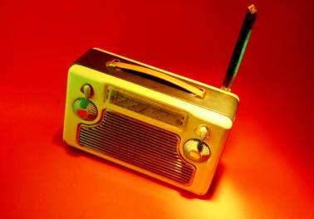

- Ultraviolet radiation is one of many types of radiation given off by the Sun. The ultraviolet radiation from the Sun takes 8 minutes to reach the Earth. How far away is the Earth from the Sun?

- What type of electromagnetic radiation is given off by a laser?

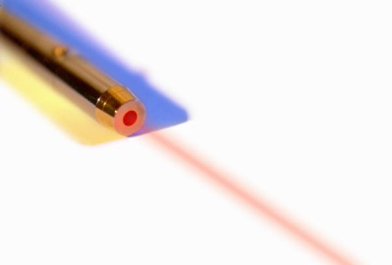

Diffraction

- What is meant by the term ‘diffraction’?

- Copy and complete these diagrams to show water waves bending around an obstacle:

(b)
(a)

- A hill lies between a radio and television transmitter and a house. The house is within the range of both the radio and television signals from the transmitter.

- The house has good radio reception but poor television reception. Suggest an explanation for this.

- A mobile phone transmitter is attached to the existing transmitter. Predict whether the mobile phone reception will be good or poor in the house. Give a reason for your answer.

- This diagram shows three types of signal in which radio waves can be sent between a transmitter and receiver.
Which of the signals has the longest wavelength? Give a reason for your answer.

Refraction

Useful Equation:
P =
f
P
1
f
1

where: P is the power of a lens (D)
f is the focal length of a lens (m)

- What is meant by the term ‘refraction’?

- What is the difference between diffraction and refraction?

- Copy this diagram and label it with the following:

Incident ray, Refracted ray, Angle of incidence, Angle of refraction, Normal.

Material 2
Material 1

- What is meant by the following statement:

“The critical angle of a glass block for red light in air is 41°.”

- Which of these diagrams shows what happens when a ray of light:

- travels from air in to glass at an angle above the critical angle of glass?

- travels from glass in to air at an angle above the critical angle of glass?

- travels from air in to water at an angle less than the critical angle of water?

- travels from water in to air at an angle less than the critical angle of water?

X
Y
Z

- A student is given a Perspex block, a pencil, a protractor, a ruler, a piece of blank A4 paper, a ray box and a power supply.
Describe how the student could use this equipment to find the critical angle of Perspex.

- Copy and complete these diagrams to show the effect the lenses have on parallel incident rays of light.

(b)
(c)
(a)

- A student makes the following statement:

“The focal length of a convex lens is 15 cm.”

What is the meaning of this statement?

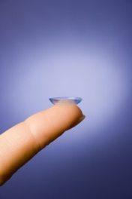
- What is the focal length of a convex lens that has a power of +4.5 D?

- What is the power of a concave lens that has a focal length of -5 cm?

- Copy and complete these ray diagrams to show the image produced. Use a separate piece of graph paper.
f
f
Convex lens
object
(a)
f
f
Convex lens
object
(b)

For each ray diagram, state whether the image is:

- Real or virtual.
- Magnified or diminished.
- Upright or inverted.

- What is the meaning of the following eye defects:
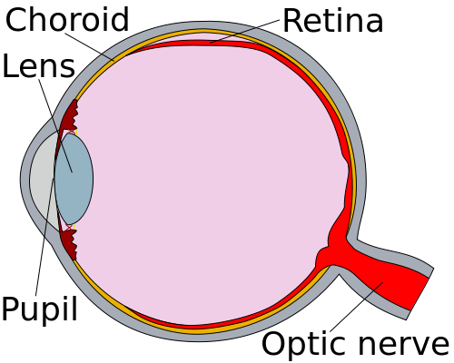
- Short sight.

- Long sight.

- What shape of lens would be used to correct the following eye defects. Use a diagram to demonstrate this.

- Short sight.

- Long sight.

- Describe how a telescope uses two convex lenses to create a magnified, virtual and inverted image of a distant object.
Objective Lens
Eyepiece Lens
Light-Tight Tube

Make reference to the focal lengths of the eyepiece and objective lenses.

- A lifeguard is looking at a swimmer in a pool. Explain, with the aid of a diagram, why the lifeguard sees the swimmer at point B rather than her actual position at point A?

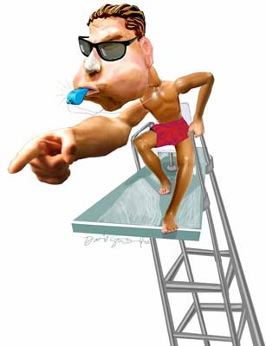
air
water
A
B

Properties of Radiation

- Describe what the following radiations are made up of.
- Alpha
- Beta
- Gamma

- What is the meaning of the term ‘ionisation’?

- Describe how these types of radiation cause ionisation of an atom?
- Alpha
- Beta
- Gamma

- Copy and complete this table to show the absorption of radiation as they travel through different materials.

 | Absorbing material
Radiation | 3 cm of Air | Piece of Paper | 3 cm of Aluminium | 3 cm of Lead
Alpha
Beta
Gamma

Put a  if the radiation will pass through the material.
Put a x if the radiation will be absorbed by the material.

- Give three safety precautions that should be followed when working with radioactive materials.

- What is background radiation?

- What are the main sources of background radiation?

- Is background radiation mostly naturally occurring or man-made?

- What effect does radiation have on living cells?

- Smoke alarms are made with an alpha source (Americium-241). Describe how a smoke alarm uses ionisation to warn people of a possible fire.
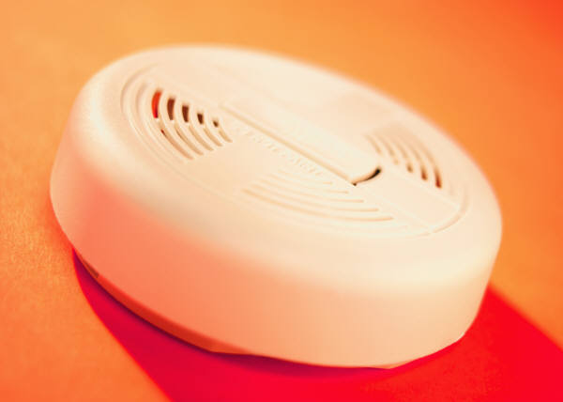

- A radioactive tracer is a gamma emitting chemical compound that can be injected in to a patient in hospital. Describe how this can be useful in diagnosis of medical problems.

- Gamma rays can also be used to treat cancer in a method known as radiotherapy. Describe how a patient can have a cancer treated in this way, and how damage to surrounding healthy tissue is minimised.

- The following equipment can be used to detect radiation. Choose one piece of equipment and describe how it detect radiation.

Geiger-Muller Tube, Film Badge, Scintillation Counter

Activity

Useful Equation:
N
A =
t
A
N
t

where: A is the activity of a source (Bq)
N is the number of decays (N)
t is the time taken (s)

- Copy and complete this table.

 | Activity / Bq | Number of Decays | Time / s
(a) |  | 720 | 60
(b) |  | 4500 | 180
(c) | 1000 |  | 100
(d) | 12 500 |  | 500
(e) | 40 000 | 3.0 x 10⁷
(f) | 2.5 x 10⁶ | 5.0 x 10⁸

- What is meant by the ‘activity’ of a source?

- What is meant by the term ‘radioactive decay’?

- What is the activity of a source that has 210 decays in a minute?

- A source has an activity of 2.0 kBq. How many counts will be recorded from the source by a Geiger-Muller tube (and counter) in 30 seconds?

- How long will it take a source with an activity of 1.8 MBq to have 8.1 x 10⁸ radioactive decays?

- Describe an experiment to find the activity of a radioactive source using the following equipment:
Stopwatch, Geiger-Muller Tube, Counter.

- In a laboratory, the background activity is measured as 1.5 Bq. A Geiger-Muller tube is used to measure the activity of a source in the laboratory. In three minutes, 1440 counts are recorded. What is the activity of the source?

- In an experiment, the number of decays from a radioactive source is recorded. The background count is then taken away. The results of this are shown.

Time / minutes | Corrected Number of Decays
0 | 0
1 | 1800
2 | 3600
3 | 5400
4 | 7200
5 | 9000

Draw a line graph of these results, and use the gradient of the straight line to calculate the activity of the source.

Half Life

- What happens to the activity of a source as it gets older?

- What is the meaning of this statement?

“The half-life of a radioactive source is 12 hours”

- A radioactive material has a half life of 8 hours. If it has an original activity of 200 kBq, what is the activity of the source a day later?

- The activity of a radioactive substance drops from 100 MBq to 6.25 MBq in 12 years. What is the half life of the substance?

- A material with a half life of 4 hours has an activity of 15 Bq at this moment. What was its activity 24 hours ago?

- A patient in a hospital is being given a radioactive tracer to find a blockage in his kidneys.
The tracer is prepared in a laboratory with an initial activity of 16 kBq. It can’t be safely given to the patient until the activity drops to 0.25 kBq.
The half life of the tracer is 6 hours, and the patient is due to be treated at 9am on Saturday. When should the tracer be prepared?

- The activity of a radioactive source is shown on this graph. What is the half-life of the source?
80
0
6
12
18
24
Activity / MBq
Time / months
160
240
320

- Describe how a student could calculate the half life of a radioactive source using this equipment.

- In a science classroom, the background count is 2.0 Bq. The measured activity of a source at different times is recorded in this table.

Time / mins | 0 | 5 | 10 | 15 | 20 | 25 | 30 | 35
Activity Recorded / Bq | 66 | 51 | 43 | 34 | 27 | 22 | 18 | 15

Draw an activity-time graph and use it to calculate the half-life of the source.

- A radiotherapist in a hospital has to decide which of five materials is to be used as a radioactive tracer. The materials and some of their properties are listed.

Material | Radiation Emitted | Half Life
A | Alpha | 4 hours
B | Gamma | 3 hours
C | Beta | 10 hours
D | Gamma | 63 years
E | Alpha | 5 minutes

Which material should the radiotherapist use? Give two reasons for your answer.
Absorbed Dose

Useful Equation:
E
D =
m
D
E
m

where: D is the absorbed dose from a radiation (Gy)
E is the energy of absorbed radiation (J)
m is the mass of material absorbing radiation (kg)

- What is the meaning of the term ‘absorbed dose’?

- Copy and complete this table.

 | Absorbed Dose / Gy | Energy/ J | Mass / kg
(a) |  | 6 x 10⁻⁶ | 0.5
(b) |  | 3.5 x 10⁻⁵ | 0.25
(c) | 8.8 x 10⁻⁵ |  | 0.05
(d) | 6.5 x 10⁻⁵ |  | 0.26
(e) | 1.1 x 10⁻⁵ | 3.3 x 10⁻⁶
(f) | 1.2 x 10⁻⁵ | 1.8 x 10⁻⁶

- What is the absorbed dose of a 400 g hand that absorbs 7 μJ of alpha particles?

- What is the mass of skin exposed to radiation with 4.2 μJ of energy if the absorbed dose is 10 μGy?

- A tumour of mass 150 g is exposed to gamma rays. The absorbed dose from this exposure is 5.1 x 10⁻⁵ μGy. What is the energy of the gamma rays absorbed by the tumour?
Equivalent Dose

Useful Equation:
D
H
W_{R}
H = D W_{R}

where: H is the equivalent dose of a radiation (Sv)
D is the absorbed dose of a radiation (Gy)
W_{R} is the radiation weighting factor

- What is the meaning of the term ‘equivalent dose’?

- Copy and complete this table.

 | Equivalent Dose /Sv | Absorbed Dose / Gy | Radiation Weighting Factor
(a) |  | 4.2 x 10⁻⁶ | 1
(b) |  | 1.7 x 10⁻⁵ | 3
(c) | 6.8 x 10⁻⁵ |  | 10
(d) | 3.5 x 10⁻⁵ |  | 20
(e) | 1.1 x 10⁻⁵ | 1.1 x 10⁻⁴
(f) | 4.5 x 10⁻⁵ | 1.5 x 10⁻⁵

- What is the equivalent dose of a patient’s tissue, if it is exposed to 1.5 μGy of slow neutrons?


- What is the absorbed dose of a patient’s foot, if it’s equivalent dose is 0.4 mSv of gamma rays?

- A piece of skin is exposed to 15 μGy of a radiation. The equivalent dose of the skin is 0.3 mSv.

- What is the weighting factor of the radiation?

- What kind of radiation has the skin likely been exposed to?

- A piece of tissue has a mass of 100 g and is exposed to 10 μJ of fast neutrons.

- What is the absorbed dose of the tissue?

- What is the equivalent dose of the tissue?

- As a part of his job, an airport security guard has to expose his hand to x-rays (W_{R} = 1) as he removes blockages from a baggage scanner.
On average, each time he does this, the absorbed dose of his hand is 0.03 μGy.

- What is the equivalent dose of his hand each time he removes a blockage?

- The safety rules in the airport state that the maximum equivalent dose for his hand in one hour is 0.6 μSv. How many times can the airport security guard safely put his hand in the scanner in an hour?

- The average annual equivalent dose of the most common sources of background radiation in the UK are shown.

Background Source | Equivalent Dose / mSv
Radon Gas (from rocks) | 1.25
Buildings | 0.35
Medical | 0.35
Food & Drink | 0.30
Cosmic Rays | 0.25
Nuclear Power & Weapons | 0.0075

Construct a bar graph or pie chart to show this information. Make sure that it is clear which sources are man-made and which are naturally occurring.

- The average person in the UK receives an background equivalent dose of 2.5 mSv per year. Why would you expect a person in Dalbeattie to have a slightly higher (yet still safe) equivalent dose?

- Radioactive substances have many uses in society, such as in medicine. However, there are also some disadvantages of using radioactivity, such as the altering and killing of living cells.
List some risks and benefits of using radioactivity in society.

Nuclear Fission and Fusion

- What is nuclear fission?

- What is a chain reaction in nuclear fission?

- How does a fission reaction create heat energy?

- Describe the purpose of each of these parts of a nuclear reactor:

Boron Control Rods, Containment Vessel, Graphite Moderator, Carbon Dioxide,
Uranium Rods

- How is the heat energy from a nuclear reactor used to generate electricity?

- What is nuclear fusion?

- How does nuclear fusion create heat energy?

- There is much debate in the UK about using nuclear power to generate electrical energy.
Construct a table that shows the advantages and disadvantages of using nuclear energy to power the country.
Answers

Wave Properties (p4)

- Energy

- Transverse waves oscillate perpendicular to the direction of travel.

- Longitudinal waves oscillate along the axis of direction of travel.

Crest
Trough
Wavelength
Amplitude

- (a) Wavelength is the
distance from the
crest of one wave to
the crest of the next
wave.
- Frequency is the number of waves in a second.
- Amplitude is the distance from the axis to the crest (or trough) of a wave.
- Wave speed is the distance that a wave travels in a second.

- (a) Wavelength = 6 m,
Amplitude = 1 m
- Wavelength = 10 m, Amplitude = 3 m
- Wavelength = 2 m, Amplitude = 0.75 m
- Wavelength = 12 m, Amplitude = 2.75 m
Wave Speed (p5)

- (a) 2.5 m s⁻¹
- 0.25 m s⁻¹
- 9.6 m
- 1190 m
- 40 s
- 5 s

- 4 m s⁻¹

- 2.4 m

- 18 s

Wave Equation (p6)

- (a) 3200 m s⁻¹
- 340 m s⁻¹
- 20 Hz
- 300 Hz
- 3 m
- 0.24 m

- 1.8 m

- 40 Hz

- 0.04 m

Sound (p7 – 8)

- Use the metre stick to place the microphones one metre apart.
Hit the side of the bottle with the knife on one side of both microphones.
Use the electronic timer to measure how long it takes for the sound to travel between the microphones.
Use v = d / t to calculate the speed of sound in air.

- (a) 1700 m
- 0.425 m

- (a) 0.1 s
- 50 000 Hz

- 0.85 m

- (a) 1900 m/s
- Glycerol

- (a) Light travels faster than
sound.
- 510 m.

Electromagnetic Spectrum
(p9 – 10)

- Radio waves
Microwaves
Infrared radiation
Visible light
Ultraviolet radiation
X-rays
Gamma rays

- 3 x 10⁸ m s⁻¹

- Wavelength decreases.

- Energy increases.

- (a) X-rays are used to
detect broken bones or
in Barium meals.
- Gamma rays are used to sterilise equipment, diagnose blood flow problems and treat cancer.
- Infrared radiation is used to treat muscle injuries and in thermograms.
- Ultraviolet radiation is used to treat skin diseases, such as psoriasis.

- (a) Radio waves are used
in radio and TV
communications.
- Microwaves are used by mobile phones.

- (a) Infrared radiation is
used by remote
controls and heaters.
- Microwaves are used to heat food.

- Gamma rays don’t diffract easily and are dangerous to humans.
- 1.09 ms

- (a) 3.08 m
- 2.2 ms

- 1.44 x 10¹¹ m

- Visible light.

Diffraction (p11)

- Diffraction is the bending of waves around an obstacle.

- (a)

(b)

- (a) Radio waves diffract
more easily because
they have a long
wavelength.
- Reception will likely be poor. Wavelength is higher than even TV waves so diffraction is less likely.

- Surface wave.
It diffracts along the surface of the Earth so must have a long wavelength.

Refraction (p12 – 13)

- Refraction is the change in speed / wavelength / direction of light as it moves from one medium to another.

- Diffraction does not involve waves changing medium.
normal
Incident ray
refracted ray
i
r

- The largest angle of incidence at which refraction of light will occur at a glass/air interface is 41°.

- (a) Z
- Z
- X
- Y

- Draw around the Perspex block.
Shine a ray of light through it and change the angle of incidence until the angle of refraction is 90°.
Mark the incident ray on the paper.
Measure the angle of incidence with the protractor.
(a)

(b)

(c)

(Shorter focal length)

- The focal length is the distance between a lens and a screen where a sharp image of a far away object can be seen.

- 0.22 m

- -20 D

- (a) i Virtual
ii Magnified
iii Upright

- i Real
ii Diminished
iii Inverted

- (a) Short sighted people can
see nearby objects clearly
but distant objects appear
blurry.
- Long sighted people can see distant objects clearly but nearby objects appear blurry.

- (a) Short sight is corrected
with a concave lens.

- Long sight is corrected with a convex lens.

- Objective lens has a focal length less than the length of the light-tight tube.
It creates an image that is real, inverted and diminished.
Eyepiece lens has a focal length bigger than the distance to the image from the objective lens.
Image is now virtual, inverted and magnified.

Properties of Radiation
(p16 – 17)

- (a) Helium nucleus
- Fast electron
- Electromagnetic wave

- Ionisation is the process by which an atom loses (or gains) an electron.

- (a) Alpha particles are
positively charged, so
attract electrons away
from nuclei.
- Beta particles are negatively charged, so repel electrons away from nuclei.
- Gamma rays are absorbed by electrons giving them the energy required to leave atoms.

- Alpha can’t pass through any materials.
Beta can pass through air and paper.
Gamma can pass through air, paper and aluminium.

- Use tongs, point source away from people, wear lead-lined clothing, keep in a lead lined container.

- Background radiation is radiation that is around us all the time.

- Radon gas, medical, buildings, food, cosmic rays.

- Natural sources.

- Radiation kills or alters cells.

- Alpha particles ionise air, allowing electrons to pass through ions, completing a circuit.
Smoke particles are not ionised so stop the circuit from completing.
An alarm sounds.

- Tracer is injected in to patient. Gamma rays leave the body and are detected by a gamma camera.
The circulatory system can then be seen.

- Gamma rays can be directed at cancer cells to kill them.
Gamma source is rotated to prevent healthy tissue being overexposed.

- G-M tube – radiation detected by a circuit being completed by ionised gas.
Film badge – radiation detected by darkening of film.
Scintillation counter – radiation detected by a small pulse of light.

Activity (p18 – 19)

- (a) 12 Bq
- 25 Bq
- 100 000
- 6 250 000
- 750 s
- 200 s

- Activity is the number of decays that happen in a second.

- Radioactivity decay is when an unstable atom emits a radioactive particle and a becomes a different element.

- 3.5 Bq

- 60 000

- 450 s

- Connect the G-M tube to the counter.
Move it close to the radioactive source.
Measure how many counts are in 30 seconds.
Calculate activity using A = N/ t.

- 6.5 Bq

- 30 Bq

Half Life (p20 – 21)

- Activity decreases.

- Half life is the time taken for the activity of a radioactive source to reach half of its original value.

- 25 kBq

- 3 years

- 960 Bq

- 9pm on Thursday

- 9 months

- Calculate the activity of a source using the G-M tube, stop watch and the counter.
Repeat this until the activity is halved.
Check how long has passed with the clock. This is the half life.

- 15 minutes

- B
Gamma can penetrate tissue.
The half-life is a reasonable value to be useful and safe.

Absorbed Dose (p22)

- Absorbed does is the amount of energy absorbed from a radiation by a kilogram of a material.

- (a) 2 x 10⁻⁵ Gy
- 1.4 x 10⁻⁴ Gy
- 4.4 μJ
- 16.9 μJ
- 0.3 kg
- 0.15 kg

- 17.5 μGy

- 0.42 kg

- 7.65 μJ

Equivalent Dose (p23 – 25)

- Equivalent dose is a measure of the biological harm of exposure to a radiation.

- (a) 4.2 μSv
- 5.1 x 10⁻⁵ Sv
- 6.8 μGy
- 1.75 μGy
- 10
- 3

- 4.5 μSv

- 0.4 mSv

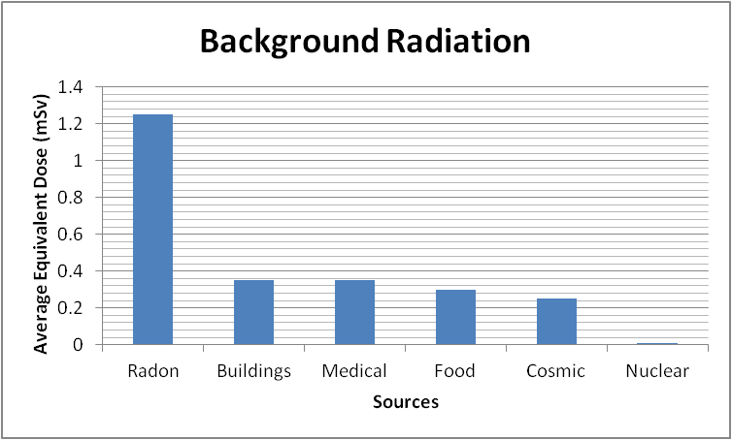
- (a) 20
- Alpha.

- (a) 1.0 x 10⁻⁴ Gy
- 1 mSv

- (a) 0.03 μSv
- 20 times.

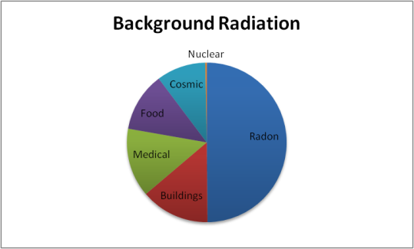
- See diagrams to right.

- Dalbeattie has a granite quarry nearby and many houses are made of this material. This is a source of Radon gas.

- Benefits: Smoke alarms, Medicine, Generation of energy.
Risks: Overexposure can kill or cause cell mutations.

Nuclear Fission and Fusion (p26)

- Nuclear fission is when a neutron collides with a nucleus, causing it to split.

- When the nucleus is split, further neutrons break off and cause further fission reactions.

- Heat energy is produced by the bonds of the nucleus breaking.

- Boron Control Rods absorb neutrons.
Graphite Moderator slows down neutrons.
Uranium Rods are the fuel for the reactions.
Carbon Dioxide cools the reactor and passes heat energy to the boiler.
The Containment Vessel stops any harmful radiation from escaping.

- Heat energy heats water in the boiler.
Water turns in to steam.
Steam turns a turbine.
The turbine turns a generator.
The generator makes electricity.

- Nuclear fusion is when two nuclei collide and combine with each other.

- Heat energy is produced when nuclei combine.

- Advantages: No air pollution, lots of energy, will last for a long time.
Disadvantages: Nuclear waste, reactor failure is potentially dangerous to millions.

