1. Heat or Temperature

Does “heat” and “temperature” mean the same thing?

We all talk about being very hot or that the temperature is very high but do these two statements mean the same thing?

Discussion: In small groups discuss the meaning of the words “heat” and “temperature”. Do the two words mean the same thing or is there a difference? Agree on a sentence containing the word “heat” and another sentence containing the word “temperature” to help explain your decision.

The following experiment will help us to find the answer to the above question.

Collect: Measuring cylinder
Thermometer
Plastic Beaker with lid
250 ml beaker

Plastic cup
40 cm³
water
Thermometer
Metal cube
lid
Water Bath
Water at 80 ºC

Two cubes of metal have been placed into a water bath. The water in the water bath is at 80 ºC.

Discussion: The metal cubes have been in the water since the beginning of the period. What temperature do you think the metal cubes are at the moment?

Activity: 1. Half fill a 250 ml beaker with water from the cold tap and place the beaker on your bench.

2. Using the water from the beaker measure out 40 cm³ of water in a measuring cylinder and then pour it into the plastic cup.

3. Measure the temperature of the water.

4. Using the metal tongs at the water bath, remove the copper (brown) cube from the water bath and place it into your plastic cup. Place the lid on and leave it for 1 minute.

5. Remove the lid and carefully stir the water with the thermometer then record the highest temperature reached.

6. Empty out the water from the plastic cup. The cube will not be hot now so catch it in your hand and dry it on a paper towel.

7. Repeat instructions 2 to 6 for the aluminium (silver) cube that is in the water bath.

Notes: Copy and complete the table below.

Type of Metal Cube | Starting Temperature  (ºC) | Temperature at End (ºC) | Rise in Temperature (ºC)

Discussion: If both cubes were at the same temperature at the start, explain why the rise in temperature for each cup of water was different.

Notes: 1. Draw a labelled diagram of the apparatus you used.

2. Write a few sentences explaining what you did in the experiment. (A method).

3. Write down two new sentences – one explaining the meaning of “temperature” and one explaining the meaning of “heat”.

- Heat on the Move

Heat is something that must be able to move. For example:

- Heat can travel from a gas flame through a pot to the food inside.
- The far corner of a room gets heated even though the heater is on the other side of the room.
- The earth is heated by the sun even though the sun is 150 million kilometres away.

Discussion: Listen to your teacher as you are shown the cartoon about ice cream. Discuss, as a class, why the bowl of ice cream starts to melt.

Heat can travel through some objects by a process called conduction. The following experiment should help you answer the problem about the ice cream.

Collect: 1 metal rod
3 rivets
Vaseline
clamp stand
heat proof mat
Bunsen burner

Metal rod stan
Clamp stand
Bunsen burner

Heat proof mat
rivets

Activity: 1. Clamp one end of the metal rod with the clamp stand and adjust the height so that the end of the rod will be level with the Bunsen flame.

- Carefully attach the three rivets to the metal rod using a small amount of Vaseline on each one. (To make the experiment fair, make sure you use the same amount of Vaseline on each rivet)

- Heat the end of the rod using the Bunsen Burner. Make sure the air hole is half open.

Discussion:
  - Which way does the heat flow through the metal rod?
  - Can you now explain why the ice cream melted?
  - What is happening in the metal when heat flows through it?

Pay attention to your teacher as this method of heat transfer is explained to you.

[Turn Over]

So far we have found out that heat can pass from one end of an object to the other. The material that the heat energy is passed through contains particles. In fact it is because of the particles in a material that the heat energy can move in this way.

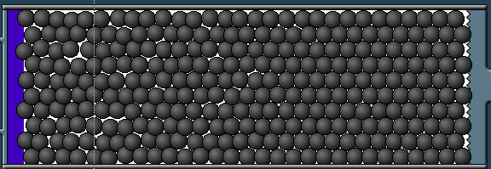
H
o
t
C
o
l
d

In the above diagram, heat is travelling from left to right. The particles on the left have more heat energy and are moving more. They pass their energy onto the particles to the right and heat energy therefore travels through the material. This method of heat transfer is called conduction.

Notes: Copy the diagram of the experiment you carried out.

Copy and complete the following sentences into your jotter.

The rivets fall off one by one showing that the heat flows from the __________ end of the rod to the __________ end.

This method of heat flow is called conduction.

The vibrating particles in the metal rod are made to vibrate faster and move further from side to side when __________. This vibration is passed from particle to particle as the heat moves along the rod.
3. Do all Metals Conduct Equally Well?

In the last lesson we discovered that heat travels through metal by conduction. There are many different metals, however. This investigation will help us to find out if all metals conduct heat equally well or are there some better than others.

You will be given a copper rod, a brass rod and a steel rod. Note that to be fair, each rod is the same thickness and the same length. The only difference is that they are made of different metals.

Discussion: In your groups plan an experiment to find the answer to the question in the title of this lesson. Think about a hypothesis too – what do you think will happen? Explain your plan to your teacher and ask if you can go ahead with the experiment.

Activity: Carry out your experiment safely.

Notes: Write up the experiment in the same way you did in the Introductory topic at the beginning of S1. i.e. your write-up should include:

      - a title
      - the aim of the experiment
      - your hypothesis (what you think will happen)
      - a labelled diagram
      - a description of your method
      - a table of results
      - a graph of your results
      - a conclusion.

- Does thickness of the rod make a difference?

Discussion: In your groups plan an experiment that will find out whether the thickness of a metal rod will make a difference to how well it conducts. Again, agree a hypothesis for this investigation and also plan how you will make the experiment fair.

When you are ready explain your plan to your teacher and ask if you can carry the experiment out.

Activity: Carry out the experiment safely.

Notes: Write up your experiment like in the last lesson. This time, when writing your method, make sure you include information about how you made the experiment fair.

- Conductors and Insulators

So far we have only looked at conduction through metals. We know that some metals are better conductors than others.

Discussion: Is it possible to group materials into “good conductors” and “bad conductors”. The following experiment compares conduction through different materials.

Notes: copy the following table into your jotter.

Material | Rod Very Hot?  Yes or no | Conductor or Insulator

Collect: 250 ml plastic beaker
5 different rods

Activity: 1. Fill in the first column of your table. (Your teacher will tell you the name of the material that each rod is made from)
Beaker of hot water
5 different rods

2. Carefully pour water from the kettle up to the 150 ml mark on your beaker.

3. Place the 5 rods into the beaker of water as shown in the diagram. Leave them for 2 minutes.

4. While they are still in the water, feel the end of each rod and fill in the middle column of your table.

We already know that materials that heat pass through are called conductors. If heat cannot pass through a material easily then it is called an insulator.

Notes: Use this new information to fill in the last column of your table.

Is Water a Conductor or an Insulator?

The aim of the following experiment is to find out if water is a conductor of heat or an insulator.

Collect: Boiling tube
Test tube holder
Marble
Small ice cube
Bunsen burner
Heat proof mat
Test tube rack

Bunsen Burner
Boiling Tube with cold water
Marble

Ice cube
Test tube tongs

Activity: 1. Pour cold water into the boiling tube until it is about ¾ full.

- Drop the piece of ice into the water. Drop the marble on top so that the ice sinks to the bottom of the boiling tube.

- Hold the boiling tube with the test tube tongs half way along the boiling tube.

- Tilt the boiling tube and heat the water at the top of the boiling tube using a Bunsen with the air hole half open. (Ensure water does not pour out of the boiling tube and ensure there is water above the point you are heating with the flame.)

- When the water at the top of the boiling tube starts to boil, remove the tube from the flame and place it in the test tub rack.

Notes: Draw a labelled diagram of the experiment.

Write a paragraph explaining what you did.

Write a sentence explaining whether water is a conductor or an insulator. (Your conclusion)

[Turn over]

Is Air a Conductor or an Insulator?

Activity: Pay attention to your teacher as the following experiment is demonstrated to you.

clamp stand
metal rod
match
Bunsen burner

Notes: Draw a labelled diagram of the above experiment.

Write a few sentences explaining what was done in the experiment. Include details of how the experiment was made fair.

Explain whether air is a conductor or an insulator.

6. Uses of Conductors and Insulators

Activity: Watch your teacher demonstrate the following experiment. Pay close attention. You will be asked to explain what happens at the end.

wooden rod
paper covering both rods
metal
rod
Bunsen Burner

Discussion: What happened to the piece of paper and why?

Notes: Draw the diagram above in your jotter. Explain what was done and what happened to the paper.

Conductors and insulators can be found almost everywhere. Conductors are used to allow heat to pass through and insulators are used to prevent heat passing through.

Discussion: Name some conductors and insulators that are found at home. What is the material that each object is made of and why is it made of this?

Activity: Copy and complete the tables below using the information from your discussion.

Conductor | Material | Why is the conductor made of this?

Insulator | Material | Why is the insulator made of this?

Notes: Answer the following questions in sentences in your jotter.

- Why do cooks prefer to use wooden spoons for stirring hot soup rather than metal ones?
- Why do most cooking pots have wooden or plastic handles?
- Why do hot water tanks have a cover over them?
- Both fridges and ovens have polystyrene in their walls. Explain why in each case.

Discussion: When the space shuttle enters the earth’s atmosphere a great deal of heat energy is produced due to the friction between the shuttle and the air. In fact the temperature of the surface of the shuttle can reach 1650ºC.

How do you think the design of the shuttle ensures that the astronauts inside do not get burned alive?

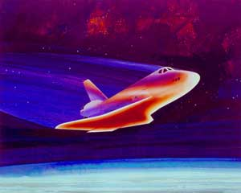

7. Convection 1

We have looked at how heat can travel through objects by conduction but conduction is only one method by which heat can travel from one place to another.

Collect: Large beaker of cold water
Bunsen Burner
Bench Mat
Tripod
Lump of dyed chalk

Activity:
Beaker of water
Tripod
Lump of dyed chalk
Bench Mat
Bunsen burner

1. Carefully drop the lump of dyed chalk down the side of the beaker of cold water.

Position the Bunsen burner at the side of the beaker under the chalk.
- Heat the beaker gently using a very small blue flame until the dye starts to move.

Discussion: What happened to the dye in the beaker?

In your group try to work out why the dye moved in this way.

Notes: Copy the labelled diagram from the previous page.

Draw arrows on your diagram to show how the water moves. i.e. how the heat flows.

Copy the following

When water is heated, the hot water rises and is replaced by the colder water as it falls. This circular movement of water is called convection current.

Mines

In the 1800s mining, like today, was a very dangerous job. One of the biggest problems was miners breathing in poisonous gases. Many miners died because there was very little fresh air deep down in a mine and therefore not enough oxygen to breathe. Nowadays large fans are used to ventilate mines and there is not the same problem.

To stop the miners dying, scientists came up with a method of ventilating the mines.

Watch your teacher demonstrate the method the scientists used.

candle
Smoking taper
Mine shaft
Mine shaft

Notes: What happened to the smoke from the taper when the candle was not lit?

What happened to the smoke when the candle was lit? Explain why this happened.

Draw the above diagram showing the path that they smoke took through the mine.

What is the name given to this type of circular motion?

Using what you have learned from this experiment, explain how it is possible to ventilate a mine by this method.

8. Convection 2

Activity: Listen to your teacher as the following experiment is explained to you. Can you predict what will happen when the glass covers are taken away?

Before
After
Hot coloured water
Hot coloured water
Cold colourless water
Cold colourless water

Notes: Copy the above diagram and complete the “After” part to show what happens.

Write a few sentences to explain what happened in the experiment.

Collect: Bunsen burner
bench mat
clamp stand with boss head and clamp
boiling tube
thermometer

Activity:
Bunsen burner
boiling tube of cold water
clamp stand
thermometer
bench mat

- Set up the above apparatus and fill the boiling tube with cold water until it is 2 cm from the top. Tilt the boiling tube but not as far as water will come out.

- Before heating. Take the temperature of the water at the top of the boiling tube.

- Gently heat the bottom of the boiling tube with a small blue flame for 30 seconds.

- Switch off the Bunsen burner.

- Take the temperature at the top of the boiling tube once more.

Discussion: While studying conduction, you found out that water is a poor conductor. In your group, try to explain what happened in this experiment. You may want to think back to the first experiment you did today.

Notes: Copy the labelled diagram on the previous page.

Use what you discussed to answer the following questions in you jotter.

- What was the temperature at the top of the boiling tube before any heating took place?
- What was the temperature at the top of the boiling tube after heating took place?
- How do you explain the rise in the temperature of the water?

9. Why does Convection Happen?

Before we find out where convection takes place in our everyday lives it will be useful to find out why it happens.

Notes: Copy the following table into your jotter.

Substance | Mass / g | Volume / cm³ | Mass of 1 cm³ / g
Wood |  | 8
Metal |  | 8
Water |  | 8

Collect: 8 cm³ metal cube
8 cm³ wooden cube
measuring cylinder
plastic beaker

Activity: Use the balance to find the mass of the wooden block and the metal block and write the results into the second column of your table. (If the reading on the balance jumps between 2 values, wait for a few seconds and choose the reading that it shows most often.)

Fill the measuring cylinder up to the 8 cm³/ml mark and find the mass. Pour out the water and find the mass of the measuring cylinder on its own. Calculate the mass of the water and write the result into the table.

Now you know the mass of 8 cm³ of each substance. You now have to find the mass of 1 cm³ of each substance. Divide each mass by 8 and write the answer into the last column of the table. If you need to, round your answer to one decimal place.
The mass of 1 cm³ of a substance is a measurement of the materials density. The greater the mass of 1 cm³, the greater the density of the substance

Notes: Copy and complete the following table to show how the densities of the 3 substances compare.

Density | Substance
Lowest
Middle
Greatest

Activity: Half fill the plastic beaker with water and gently place the metal cube and the wooden cube into the water.

Notes: What happened to the cubes when you placed them into the tub of water?

Referring the table above, can you see a link between the density of a substance and whether it floats or sinks in water? If so, write down the link using the word density in your answer.

Now we can use what we have learned to explain convection.

Discussion: What happens to the spaces between the particles of a substance when it is heated?

Cold water in beaker
Hot water in beaker

The water expands when it is heated. The particles move apart and therefore the water has a greater volume.

Discussion: Although the particles have moved apart, has the number of particles in the water changed as it was heated?

Cold water in beaker
Hot water in beaker
1 cm³ of cold water
1 cm³ of hot water

Discussion: Remembering that the particles in the hot water have spaced out, how will the mass of 1 cm³ of hot water compare to 1 cm³ of cold water?

Notes: Using everything you have leaned today, write a paragraph explaining why hot water rises up through colder water when it is heated. Use the word density in your answer.
10. Convection at work

Convection currents are responsible for many things, which happen in nature.

Have you ever noticed that it is almost always breezy at the coast? Sometimes the wind blows in from the sea and at other times the wind blows out to sea from the land.

Listen carefully as your teacher explains why these breezes take place.

Notes: Draw 2 labelled diagrams, one to show how a sea breeze is formed and one to show how a land breeze is formed.

Collect: piece of card
scissors
bunsen burner
bench mat
pin

Activity: Draw a spiral on your card like the one shown below. 1 cm between the lines works the best.

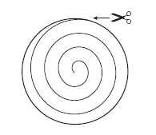

Cut out the spiral.

Insert the pin up through the top of the spiral so that you can hold the spiral by the pin.

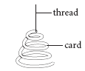
pin

Hold the spiral, using the pin, above a Bunsen with a very small yellow flame. Do not allow the spiral to touch the flame.

Notes: Draw a labelled diagram of this experiment.

Write a paragraph to say what your did.

Write down what happened to the spiral.

Use your knowledge of convection to explain what happened to the spiral.

11. Radiation

Activity: Watch and listen carefully as your teacher describes the following experiment.
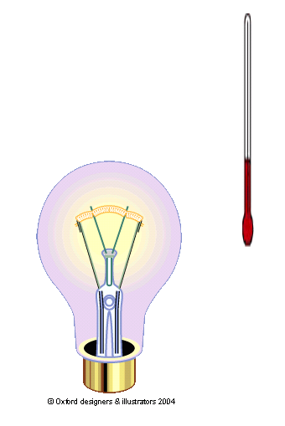
thermometer
Carbon filament bulb (source of heat)

Notes: Draw the above diagram.

What happened to the reading on the thermometer when it was held at the side of the bulb for a few minutes?

Did the heat travel to the thermometer by conduction? Explain.

Did the heat travel to the thermometer by convection? Explain.

This third method of heat transfer is called radiation. We will now find how it is different to both conduction and convection.
In lesson 2 we found out that conduction is the flow of heat energy through a material by vibrating particles passing on their energy.

In lessons 7 and 8 we found out that convection was the flow of heat energy upwards. For this to happen the particles in the substance have to be able to move position. The moving particles carry the heat energy. Note that the particles in a solid cannot move position therefore convection can only take place in liquids and gases.

In both conduction and convection particles are involved in the transfer of heat. With radiation this does not happen.

Discussion: Heat energy reaches earth from the sun. How does it get here?
What is space made of?

Notes: Copy the following table into your jotter.

Time / minutes | 0 | 1 | 2 | 3 | 4 | 5 | 6 | 7 | 8 | 9 | 10
Temperature of black tube / ºC
Temperature of silver tube / ºC

Collect: black boiling tube
silver boiling tube
test-tube rack
two rubber stoppers with thermometers
stop clock

Activity:
thermometer
test-tube rack
Rubber stopper
black
boiling-tube of hot water
silver
boiling-tube of hot water

Usually heat is transferred in all three ways at the same time. In this experiment both tubes will cool down. There will not be much convection because the rubber stoppers keep the heat in. There will not be much conduction because the tubes are surrounded by air (an insulator). We can assume then that most of the heat will be lost by radiation.

The aim of this experiment is to find out which colour of tube is the best radiator of heat.

Read all of the following instructions carefully before you begin the experiment.

- Place the boiling-tubes into the rack.
- Pour equal volumes of hot water from a kettle into each tube (your teacher may do this for you). Make sure there is enough room at the top to fit the stoppers in without the water overflowing.
- Carefully fit the stoppers with thermometers into the tubes.
- Immediately take the temperature of the water in each tube and record the temperature in your table. This is your starting temperature at time of 0 minutes.
- Record the temperature of each tube of water every minute for 10 minutes.
- Leave the experiment to cool. You can tidy it away after you have written up the experiment. Make sure that you do your written work well away from the boiling tubes so that there is no chance that you will knock them down.

Notes: Now write up the experiment. Make sure you your write-up contains each of the following.

      - A title.
      - An aim.
      - A labelled diagram.
      - A table of results (already done)
      - A line graph (showing both lines on the same graph).
      - A conclusion.

12. Absorption of Radiation

Discussion: What do the words “absorb” and “absorption” mean?
In lesson 11 we found out that black objects radiate heat better than shiny objects. Which objects will absorb more heat energy? Look at the Concept Cartoon shown by your teacher.

The aim of this experiment is to find out what colours absorb heat radiation the best.

Collect: 2 clamp stands with boss heads and clamps
Bunsen burner
bench mat
metal plate with 1 black and 1 shiny side
metal plate with 2 shiny sides
2 rivets
Vaseline
10cm
Activity:

- Clamp both metal plates and position them 10 cm apart. Make sure the black side is facing the Bunsen.
- Using and equal mass of Vaseline, stick a rivet to the back of each plate. (Opposite side to the Bunsen).
- Position the Bunsen exactly half way between each plate and light it.
- Turn the collar of the Bunsen until the air hole is fully open.
- Switch of the Bunsen after a maximum of 5 minutes.
Notes: Copy out the diagram of this experiment. Make sure you label each piece of apparatus.

What happened is this experiment?

Write down a conclusion. Make sure you refer to the aim of the experiment.

Notes: Copy out the following table.

Type of surface | Temperature  at start / ºC | Temperature  at end / ºC | Temperature  rise / ºC
black
shiny

Activity: Pay attention as your teacher explains the following experiment.

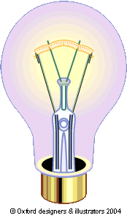
Black boiling-tube full of air
shiny boiling-tube full of air

Notes: Copy and label the diagram for this experiment.

After discussion with your teacher fill in the table of results for this experiment.

Which of the boiling-tubes showed the biggest rise in temperature?
Which colour is best at absorbing heat?

Discussion: Why does the shiny boiling-tube not allow the temperature of the air inside to rise as much?

Why do we know that the air is heated by radiation and not convection or conduction?

13. Preventing Heat Transfer

Most homes will have a vacuum flask in it. Usually it is used for keeping tea or coffee hot. The hot liquid is insulated from the cold outside and keeps hot for several hours.

The vacuum flask was originally invented by a Scottish scientist called Sir James Dewar and was originally called a Dewar Flask.

The strange fact is, however, that he designed the flask to keep liquids inside cold and not hot. The same insulation that keeps tea or coffee hot can be used to stop heat getting into the flask and therefore keeping the inside cold.

Activity: Listen carefully as your teacher sets up the following experiment.

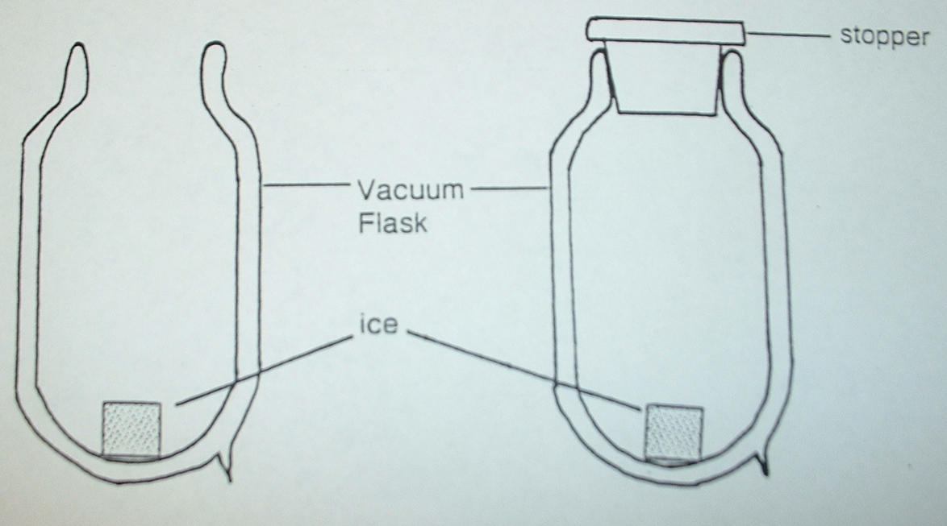

Discussion: After 20 minutes we will look at the two pieces of ice. What do you think will happen to them?
While we are waiting, let us consider a vacuum flask full of hot
tea. There must be reasons why the tea stays hot. Remember heat moves from one place to another by conduction, convection and radiation. In this case heat is prevented from moving out of the flask.

Notes: The diagram below shows you the different parts of a vacuum flask. Draw the labelled diagram into your jotter.

Consider each of the following parts of the flask. Write each part down and beside it explain how it is helping reduce the amount of heat that is escaping from the flask. Remember to use the words conduction, convection and radiation.

- Plastic lid
- Vacuum
- Shiny, glass walls
- Plastic support

Results from the Experiment

Discussion: In groups, discuss what happened in this experiment.
Think about why the experiment was done in this way (the aim).
Have you ever seen places that are designed to keep things cold but don’t have lids?
Why does this work?

Notes: 1. Write down the aim of this experiment.
2. Write a paragraph explaining what was done in the experiment.
3. Did the lid make a difference to the piece of ice?
4. Explain where you have seen this happening in everyday life.

(Turn over)

Another object that is present in most houses is a hot water tank. The diagram below shows a hot water tank with an electric immersion heater in it to provide the heat.

Cold water inlet
Hot water outlet
lagging
Immersion heater

Discussion: In groups consider the following questions.
Why is the hot water tank lagged?
Why does the cold water come in at the bottom and the hot water leave at the top?
Why is the immersion heater positioned near the bottom of the tank?
Why is there no lagging at the bottom of the tank?

Notes: Draw a labelled diagram of the hot water tank.

Write a few sentences explaining how the hot water tank works. Include the answers to your discussion questions.

14. Preventing Heat Loss at Home

Every time we pick up a newspaper or switch on a TV there seems to be something about saving energy. We found out in “Our Physical World – Part 1” that fossil fuels are running out.

What can we do to save energy?

Very often there is energy used in the house when it doesn’t have to be. It is wasted. The central heating system switches on when the house gets below a certain temperature. If we can keep more of the heat in the house without it escaping then the heating system does not have to be switched on so often.

Watch and listen to your teacher explain about where heat is lost in the home.

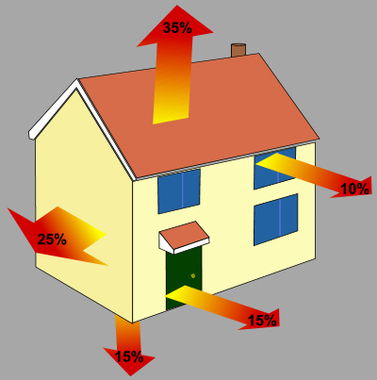

Now we will carry out an experiment to see if double-glazing really does cut down on the amount of heat lost from your house.

Notes: Copy out the following table.

Time / minutes | 0 | 2 | 4 | 6 | 8 | 10 | 12 | 14
Temperature in single
glazed beaker / ºC

Temperature in double
glazed beaker / ºC

Collect: 1 single glazed beaker
1 double glazed beaker
2 lids
2 thermometers
bench mat

Activity: Read through all the instructions below before you start the experiment. Ask your teacher if there is something you do not understand.

      - Pour hot water from the kettle into each beaker up to the 80 ml mark. Immediately place the lid on each beaker.
      - Insert a thermometer into each beaker and when the liquid in the thermometer stops rising note the temperature in your table under 0. Start your stop clock.
      - Every 2 minutes take the temperature reading from each beaker and note the reading in your table.
      - Leave your apparatus to cool.

Notes: Write up your experiment. Include the following points in your write up.

      - Title.
      - Aim.
      - Labelled diagram.
      - Method (what you did).
      - Graph of results. Plot both lines on same graph.
      - Conclusion.
      - What you did to keep the experiment fair.

