Knox Academy
Science Department

S1 Science
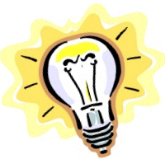
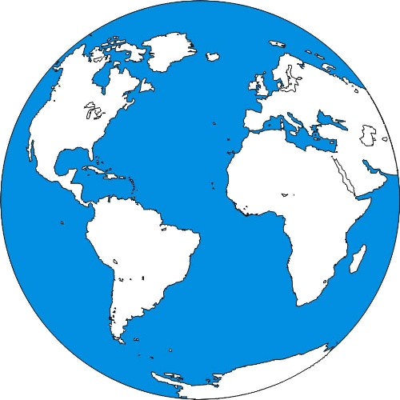

Our Physical World
Part 2

Write on Booklet
1. Heat or temperature?

Does “heat” and “temperature” mean the same thing?

Acivity

Type of Metal Cube | Starting Temperature  (ºC) | Temperature at End (ºC) | Rise in Temperature (ºC)

Complete the labels
Water Bath
Water at 80 ºC
_________ cube
_________ cube

Label the diagram using the words in the box below.
Plastic cup
Thermometer Metal cube

40 cm³ water lid

Use the word bank to complete the following sentences
lid water beaker stirred more energy temperature blocks 80 ºC

The temperature of the water in the water bath was ______. This means that each of the metal ________ was also at 80 ºC.

40 ml of _________ was poured into a plastic ________ and the _____________ of the water was noted. One block of metal was placed into a plastic beaker and a _______ was placed on top. After 1 minute the lid was removed, the water was ___________ and the temperature of the water was taken again.

One of the blocks heated up the water _______ than the other block. So even though each block started at 80 ºC, each one contained a different amount of _________.


Heat is a type of energy.
Temperature is a measurement of how hot or cold something is.

2. Heat on the move

Heat can travel through some objects by a process called conduction. The following experiment should help you answer the problem about the ice cream.

Label the diagram using the words in the box below

_______

clamp stand metal rod stand

Bunsen burner heat proof mat rivets

Fill in the blanks using the words in the box below.

The rivets fall off one by one showing that the heat flows from the _________end of the rod to the __________end.

This method is called ___________.

The vibrating particles in the metal rod are made to vibrate faster and move further from side to side when __________. This vibration is passed from particle to particle as the heat moves along the rod.

cold heated conduction hot

3. Do all metals conduct equally well?

Use the words below to complete the write-up of this experiment.

Word Bank metals time rivet conducts

Title - Do all metals conduct equally well?

Aim - My aim is to find out if all ____________ conduct equally well.

Hypothesis - I think that all metals will/will not conduct equally well. (Score out the wrong answer)

Diagram of experiment. (Label the diagram. Get help from the diagram in lesson 2)

Table of results

Type of rod | _________ for rivet to fall off (seconds)
Copper
Brass
Steel

Graph of results (Complete the Bar Graph)

Copper
Brass
Steel
Time for ________

to fall off (seconds)

Conclusion - My conclusion is that some metals ____________ heat better than others.

4. Does thickness of the rod make a difference?

Use the words below to complete the write-up of this experiment.
Word Bank metal thick seconds rivet fair thin time thickness

Title – Does the thickness of a rod make a difference to how well a metal conducts?

Aim - My aim is to find out if the _________ of a rod makes a difference to how well a metal conducts.

Hypothesis - I think that the thicker the rod the better/worse it will conduct. (Score out the wrong answer)

Diagram of experiment. (Label the diagram. Get help from the diagram in lessons 2 and 3)

Table of results

Thickness of rod | _________ for rivet to fall off (_________)
Thin
Medium
Thick

Graph of results (Complete the Bar Graph)

Thin
Medium
Thick
Time for ________

to fall off (seconds)

I made the experiment ________ by using the same amount of Vaseline for each rivet and using the same type of _________ for each rod.

Conclusion - My conclusion is that ________ metal rods conduct heat better than _________ metal rods.

- Conductors and Insulators

Are some materials better conductors than others?

5 different rods were placed into a beaker of very hot water.

After 2 minutes the tops of the rods were touched and the middle column of the table below was completed to say whether each rod was very hot or not

Very hot rods are conductors. If the rod is only warm then it is an insulator.
Beaker of hot water
5 different rods

Material | Rod Very Hot?  Yes or no | Conductor or Insulator
We already know that materials that heat pass through are called conductors. If heat cannot pass through a material easily then it is called an insulator.

Is water a conductor or insulator?

Use the words in the box below to label the parts

test tube tongs ice cube marble

boiling tube with cold water Bunsen Burner

Conductors and Insulators experiment

Below is a description of the experiment.
Complete the description by choosing the words from the box below.

Aim - To find out if water is a conductor or an insulator.

Description of the experiment

First I poured _____ _______ into the boiling tube until it was three quarters full.

Then I dropped a piece of _____ into the water and put a _______ on top to make the ice sink to the bottom of the tube.

Then I _________ the water carefully using the Bunsen burner.

When the water began to _______ I removed the tube from the flame and put it on a test tube rack.

What happened
I found out that water at one end had a temperature of ______ and the ice at the other end was at ______.

Conclusion
This means that the heat did _____ flow through the water well so water is an _________.

0 ºC cold water insulator boil

100 ºC not marble heated ice
Is Air a conductor or insulator?

Use the words in the box to label the diagram

clamp stand metal rod Bunsen burner match

Choose the words from the box below to complete the description.

Aim - To find out if air is a conductor or an insulator

Description of experiment
The left match is placed 5cm from the flame. There is _______ between this match and the flame. The right match is also 5cm from the flame. This time there is a _______ rod between the match and the flame.

What happened
The match attached to the metal ____ quickly. The left match ______ lit.

Conclusion - Air is an _____________.
lit air insulator

never metal

6. Uses of conductors and insulators

Label the apparatus using the words in the box below.
Bunsen Burner

Paper covering both rods metal rod wooden rod

The experiment is described below. Fill in the blank spaces. Use the words in the box below to help you.

Aim of the experiment
To see which material is a conductor and which is an insulator.

Description of experiment
__________ was wrapped tightly round a metal and a _________ rod. Using a blue flame the paper was ________ back and forward, allowing the flame to touch the paper.

What happened
The paper above the metal was still ________ but the paper above the wood was brown or black.

Conclusion
Metal has __________ the heat away from the paper and the paper was not hot enough to get _______. The paper above the wood was burned because wood is an _________ and cannot take heat away.
Paper wooden conducted burned white insulator moved

Conductors and insulators found in the home

Think of objects from home. Some of them will be designed to be conductors and some designed to be insulators. Complete the tables below after discussing your ideas with others in the class.

Conductor | Material | Why is the conductor made of this?

Insulator | Material | Why is the insulator made of this?

Complete the statement using the words in the box below.

Fridges have polystyrene in their ______ to prevent heat from the outside _________ through into the _______. Ovens have polystyrene in their walls to prevent heat from the _______ conducting through into the ________.

wallsfridgeinside

kitchenconducting

7. Convection 1

- Label the diagram using the words in the box below.
- Draw arrows to show how the water moves in the beaker.

crystal of dye beaker of water

Bunsen burner tripod bench mat

When water is heated, the hot water rises and is replaced by the colder water as it falls. This circular movement of water is called convection current.

Mines and safety
Draw in the path that the smoke
Smoking taper
Mine shaft
Mine shaft
candle
travels through the mine.

Fill in the blanks using the words in the box below.

When the candle was not lit, the smoke just rose away from the taper as normal.

When the candle was lit, the __________came down the mineshaft, moved along __________ the candle and then up the second shaft. This happened because the __________ around the candle became __________ and started to rise. Cold air __________ down the other mineshaft to replace it. This cold air carried the smoke with it.

This type of circular motion is called a __________ current.

Fresh air would normally fall down into the shaft as hot air rises out of another shaft. The fresh air would move through the mine ventilating it.
hot smoke convection
air fell towards

8. Convection 2

Colour and label the second set of jars to show what happened afterwards.

Before
After
Hot coloured water
Hot coloured water
Cold colourless water
Cold colourless water

Write in the words which describe each stage of the experiment. Choose the words from the box below.

Task | Stage of the experiment
 | To find out whether hot water rises or falls and also whether cold water rises or falls.
 | Pairs of glass tubes were filled with hot and cold water. The hot water was dyed purple. In the first pair the hot water was on top and the cold water was below. In the second pair this was reversed. The tubes were separated by glass covers.
 | When the glass covers were taken away, in the left hand pair, the hot coloured water remained on top and cold water stayed on the bottom. In the right hand pair, the liquids quickly mixed together and the water turned a lighter shade of purple.
 | Hot water rises and cold water falls.

Description Conclusion

What happened Aim

Use the words in the box below to label the diagram
clamp stand

bench mat

thermometer

boiling tube of cold water
Bunsen burner

Complete the answers to these statements

1. The temperature at the top of the boiling tube before any heating took place was ______.

2. The temperature at the top of the boiling tube after heating took place was ________.

3. The water at the top heats up because the water at the bottom heats up and _______ to the top by _________.

9. Why does convection happen?

Complete the table below and stick it in your jotter

Substance | Mass / g | Volume / cm³ | Mass of 1 cm³ / g
Wood |  | 8
Metal |  | 8
Water |  | 8

Complete the following table to show how the densities of the substances compare.
Density | Substance
Lowest
Middle
Greatest

Complete theses sentences using the words in the box below.

When the cubes are placed in the_______, the metal cube ______ and the wooden cube ________.

Wood has a smaller ________ than water and therefore floats in it.
Metal has a _______ density than water and therefore ________.

sinks density sinks floats higher water

Why does hot water rise up through colder water when it is heated?

Fill in the blanks using the words in the box below.

- As ______ is heated it expands as the particles move ________.
- The mass of 1cm³ of hot water is ______ than the mass of 1cm³ of cold water, therefore the ________ of hot water is less than the density of _____ water.
- Substances with a lower density ________ on substances of a higher density.

This explains why hot water rises upward moving above the cold water.

density water less cold float apart

10. Convection at work

Use the presentation from your teacher to label the following diagram to show how a sea breeze is formed.
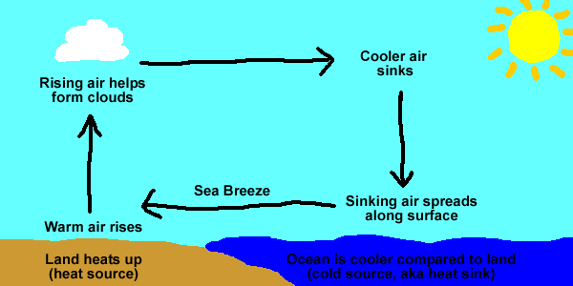

Use the presentation from your teacher to label the following diagram to show how a land breeze is formed.

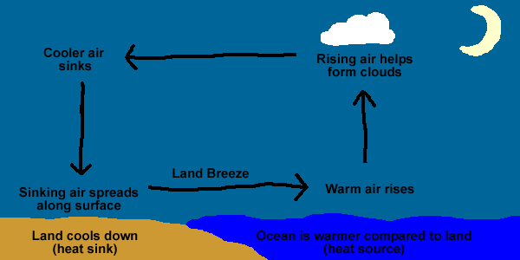

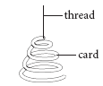

Complete the description of the experiment using the words below.

Description of the experiment

I inserted the __________ up through the top of the __________. I held the spiral by the pin above a Bunsen burner using a very __________flame.

What happened
The __________ was heated by the Bunsen flame and therefore __________through the cooler air above. As the __________ hot air hit the card, it pushed it making the spiral __________.

rising spiral rose turn

pin air small

11. Radiation

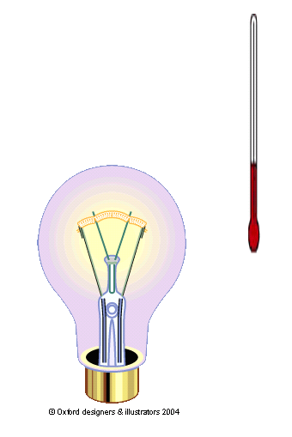
thermometer
Carbon filament bulb (source of heat)

Complete these sentences using the words in the box below.

When the thermometer was held at the ______ of the bulb, the temperature reading ________.

The heat did ______travel to the thermometer by conduction because air is a ________conductor.

The heat did not travel by __________because heat travels upwards by convection, not__________.

increased side poor convection

sideways not

Activity

thermometer
Rubber stopper
black
boiling-tube of hot water
test-tube
rack
silver
boiling-tube of hot water

Complete the table below as the water cools.

Time / minutes | 0 | 1 | 2 | 3 | 4 | 5 | 6 | 7 | 8 | 9 | 10
Temperature of black tube / ºC
Temperature of silver tube / ºC

Use the word bank below to complete the write-up of this experiment.

Black water temperature silver time minute thermometers tube

Title – Cooling down

Aim – To find out if black objects or silver objects radiate heat the best.

What was done (Method)

Boiled water from a kettle was poured into a black boiling ______ and a _______ boiling tube. The stoppers and ____________ were put in straight away and the temperature of the _______ measured at the start and also after every _________ for ten minutes.

Line Graph – Draw a line showing the temperature change of the water in the black boiling tube. On the same graph draw a similar line for the silver boiling tube.

Remember to label the axis of the graph and put a scale on.

_____________

in ºC

______ in minutes

Conclusion - ______________ objects radiate heat the best.

12. Absorption of Radiation

Aim of experiment
What colours absorb radiation best?

Diagram of experiment

Use these words to label experiment:

10cm rivet shiny plate black plate

Use the words below to help you write what happened in the experiment and what conclusion you reached
black shiny plate rivet heat absorb

What happened

The ______ from the Bunsen heated the plates. The Vaseline on the ______ plate started to melt first and the ______ on the black plate fell off the ______.

Conclusion

Black objects _______ heat better than ______ objects.

Activity
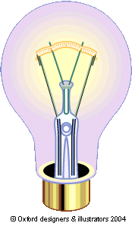
Black boiling-tube full of air
shiny boiling-tube full of air

Type of surface | Temperature  at start / ºC | Temperature  at end / ºC | Temperature  rise / ºC
black
shiny

Answer these questions

Which of the boiling-tubes showed the biggest rise in temperature?

_______________________

What colour is best at absorbing heat?

_______________________

13. Preventing heat transfer

How do all the parts of a vacuum flask help to reduce the amount of heat escaping from the flask?

Use the words from the word bank below to explain how a vacuum flask works.
conduction convection reflect insulator rising outside

conducted radiation no insulator prevents heat

The plastic lid
The plastic lid __________the hot air from _________out of the flask by___________. Plastic is an _________ so the heat from the hot air touching the lid will not be _________to the outside.

Vacuum
There are ___ particles in a vacuum therefore heat cannot travel by convection or__________.
Shiny glass walls.
Shiny walls __________ the heat back into the flask reducing heat loss by ___________. Glass is an __________ therefore prevents conduction.

Plastic support
Plastic is an insulator therefore prevents _______ conducting through to the __________.

Vacuum Flask experiment.
Use the word bank below to complete the sentences to the describe this experiment
difference Lid open rises minutes freezers ice

Aim of the experiment
To see if having a ____ on a flask makes a difference to how quick ice melts.

Method
A piece of _____ was placed into two different flasks. The lid was placed on one flask and the other left ______. The flasks were left for 20 ________ and the volume of water in each flask was compared.

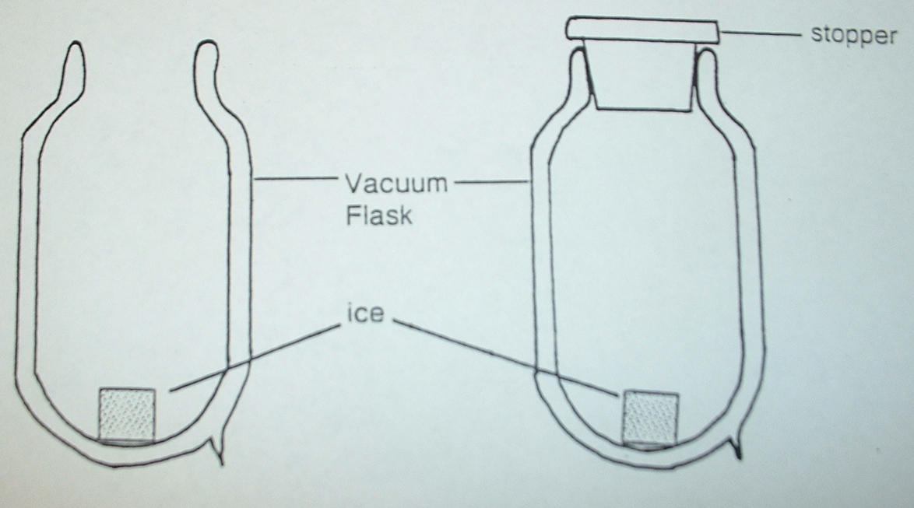

What happened?
Having a lid on made no ____________ to the amount of water.
Where does this happen in everyday life?
Some __________ in shops don’t have lids but the still keep the food inside frozen.

Why does this work?
Heat ______ so no heat falls down into the freezer to melt the food.

Hot water tank

Label the diagram using the following words

cold water inlet lagging

hot water outlet Immersion heater

Use the word bank below to complete the sentence describing how a hot water tank works.

cold hot tank bottom conduction rises heater

The water tank is lagged to prevent heat loss by ___________.

_______ water comes in at the bottom so that it is close to the immersion _________.

_____ water leaves at the top because, as the water is heated, it ________ to the top of the tank.

The immersion heater is positioned near the bottom of the ______ so that it heats as much water as possible.

There no lagging at the ________ of the tank because the water there is cold so heat will not leave from there.

14. Preventing heat loss at home

Activity

Time / minutes | 0 | 2 | 4 | 6 | 8 | 10 | 12 | 14
Temperature in single
glazed beaker / ºC

Temperature in double
glazed beaker / ºC

Title of experiment – Does Double Glazing Work?

Aim – To find out if double glazed windows prevent heat loss better than single glazed windows.

Label the diagram

Method – what you did

Graph of results
0 2 4 6 8 10 12 14
_______________________ ________________________
__________

Conclusion

How you made the experiment fair.

